

User’s Guide

OpenHospital

An product

Table of Contents

Table of Contents 2

1 Abstract 5

2 Introduction 6

3 Useful Information before reading this user manual. 7

3.1 Help 7

3.2 Legenda 7

4 Run the application 9

5 Outpatient Department Management (OPD) 11

5.1 Main Characteristics 11

5.2 Functions of Out Patient Department 11

5.2.1 Search patient visits (Search) 12

5.2.2 Create a new patient visit (New) 13

5.2.3 Modify a recorded patient visit (Edit) 14

5.2.4 Delete a recorded patient visit (Delete) 15

5.3 OPD Extended (OPD v1.3) 16

5.3.1 New features 16

6 Pharmacy (Pharmacy) 18

6.1 Pharmaceuticals (Pharmaceuticals) 18

6.1.1 Main Characteristics 18

6.1.2 Functions of pharmaceuticals 18

6.2 Pharmaceutical Stock (Pharmaceutical Stock) 22

6.2.1 Main Characteristics 22

6.2.2 Functions of Pharmaceuticals Stock 22

6.3 Pharmaceuticals Stock Ward (Pharmaceuticals Stock Ward) 27

6.3.1 Main Characteristics 27

6.3.2 Functions of Pharmaceuticals Stock Ward 28

7 Laboratory (Laboratory) 32

7.1 Main Characteristics 32

7.2 Functions of Laboratory 32

7.2.1 Search of Laboratory exams (Search) 33

7.2.2 Create a new laboratory exam (New) 34

7.2.3 Modify a laboratory exam (Edit) 36

7.2.4 Delete Laboratory Exam (Delete) 37

7.3 Laboratory Extended (v.1.1) 37

7.3.1 New Laboratory Browsing (v 1.1.) 37

7.3.2 New Laboratory Exam (v. 2.0) 38

7.3.3 Laboratory Multiple Insert 39

8 Accounting (Accounting) 41

8.1 Main Characteristics 41

8.2 Functions of Accounting 41

8.2.1 Insert a new bill (New Bill) 43

8.2.2 Edit an existing bill (Edit Bill) 49

8.2.3 Delete a bill (Delete Bill) 49

8.2.4 Reports (Report) 49

8.3 Functions of Accounting in multi-user mode 50

9 Vaccines (Patient Vaccines) 53

9.1 Main Characteristics 53

9.2 Functions of Admission/Patients 53

9.2.1 Search vaccinations 54

9.2.2 Insert a new vaccination (New) 55

9.2.3 Modify data of a recorded Patient vaccination (Edit) 56

9.2.4 Delete a Patient vaccination (Delete) 56

9.3 Vaccines Extended (Patient Vaccines) 57

9.3.1 New Vaccine Browsing (v 1.1.) 57

10 Admission/Patient (Admission/Patient) 58

10.1 Main Characteristics 58

10.2 Functions of Admission/Patients 58

10.2.1 Search patient 59

10.2.2 Search patient Enhanced 60

10.3 Insert a new Patient (New Patient) 60

10.3.1 Modify data of a recorded Patient (Edit Patient) 61

10.3.2 Delete a Patient (Delete Patient) 62

10.4 Insert a new Patient Extended (New Patient) 62

10.4.1 New features 63

10.4.2 Height and Weight functionality (Height and Weight) 64

10.4.3 Patient Photo (New Photo) 64

10.5 Admission functions (Admission) 66

10.5.1 Start the admission of a patient (Admission) 66

10.5.2 Insert/modify Surgery data 68

10.5.3 Insert/modify Delivery data 69

10.5.4 Discharge of a patient (Admission) 69

10.6 OPD (OPD) 70

10.7 Bill (Bill) 70

10.8 Manage Patient historical data (DATA) 71

10.8.1 Modify data of an admission or out-patient visit (EDIT) 72

10.8.2 Delete an admission (DELETE) 72

10.8.3 Manage malnutrition control of a patient (Malnutrition control) 72

10.9 Clinical Sheet (Clinical sheet) 74

10.10 Therapy management (Therapy) 74

10.10.1 Add a therapy (Add Therapy) 75

10.10.2 Modify a therapy (Edit Therapy) 76

10.10.3 Remove a therapy (Remove Therapy) 77

10.10.4 Check availability of the pharmaceuticals (Check availability) 77

10.10.5 Save function (SAVE) 78

10.10.6 Close function (Close) 79

10.10.7 Notify & SMS (not yet implemented) 79

10.11 Merge function (Merge) 79

10.11.1 Different Names 80

10.11.2 Different Sex 80

11 Statistics (Statistics) 82

11.1 Main Characteristics 82

11.2 Report Launcher (Launch Report) 83

12 Printing (Printing) 85

12.1 Main Characteristics 85

12.2 Printing 85

12.2.1 Exams List (Exams List) 86

12.2.2 Disease List (Disease List) 86

13 Communication (Communication) 87

13.1 Main Characteristics 87

13.2 Chat 87

13.3 Admission/Discharge Notifications 88

13.3.1 Admission Notifications 89

13.3.2 Discharge Notifications 90

13.4 Pharmaceuticals Critical Level Notifications 90

13.5 Report sharing 92

14 General Data (General Data) 93

14.1 Main Characteristics 93

14.2 Types (Types) 93

14.2.1 Admission Types (Admission Type) 95

14.2.2 Discharge Types (Discharge Type) 95

14.2.3 Delivery Types (Delivery Type) 96

14.2.4 Delivery Result Types (Delivery Result Type) 96

14.2.5 Disease Types (Disease Type) 97

14.2.6 Exam Types (Exam Type) 97

14.2.7 Medicals Stock Movement Types (Medicals Stock Mov Type) 98

14.2.8 Medical Types (Medical Type) 99

14.2.9 Operation Types (Operation Type) 99

14.2.10 Pregnant Treatment Types (Pregnant Treatment Type) 100

14.2.11 Other Prices (Other Prices) 100

14.2.12 Age Types (Age Type) 102

14.2.13 Vaccine Types (Vaccine Type) 104

14.3 Hospital (Hospital) 104

14.4 Ward (Ward) 105

14.5 Disease (Disease) 106

14.6 Exam (Exams) 108

14.6.1 Results (Results) 109

14.7 Operations (Operation) 110

14.8 Vaccine (Vaccine) 111

14.9 Prices (Price Lists) 111

14.9.1 Pricelists (*Manage Lists*) 113

15 Users & Groups (File -> Users) 115

15.1 Groups (Groups) 115

15.2 Users (Users) 118

# Abstract

This application is the first of a set of software products that ISF[1] has developed to support the management and the activities of the St. Luke Hospital in Angal (Uganda). After that mission, the St. Luke Hospital has become only the first one of a long list of hospitals that found this software useful.

All the work was realized as an open-source[2] project using only open-source development software.

This application software consists of the following parts:

* Pharmacy management
* Laboratory management
* OPD management
* Patient admission and discharge management
* Pregnancy management
* Malnutrition control management
* Vaccines database
* Patient billing support
* Therapy management
* Internal communication
* Statistics and printing

This document describes how all the above-mentioned items work and gives you some suggestions on the correct use of the program.

The reader will not find in this manual the information he needs for the installation of the application software or for administrative purposes; to have such information you should consult our Administrator’s Guide, supplied with the application software.

# Introduction

The aim of this program is to manage, in the simplest manner, the hospital administrative operations like registering patients and laboratory analysis, and to produce statistics for the health ministry. In the following chapters the users will find all the information they need in order to use properly the program.

# Useful Information before reading this user manual.

## Help

* The **HELP** function available on the bottom of the main MENU of OpenHospital allows you to access offline this document.

## Legenda

In this document will be used following conventions:

* When in the text of this document you find a word written in bold and highlighted in grey **–** like **Pharmacy** or **New –** it indicates a function of the application and it is also called “button”. **Pharmacy** is a button.
* When you find a text written in bold Italic (as an example ***Laboratory browsing)*** it indicates the screen with name “Laboratory browsing” (see example below). Each screen of the application is called window. ***Laboratory browsing*** is a window.
* When you find a text written in bold as - **Search patient visits –** it indicates a function of the application, or an area of the window (as an example **Data table**).
* Each button has always one letter with an underscore. You can select the functionality offered by the button pressing the “Alt” key and at the same time the “underscored” key (in the example of **Pharmacy** you have to press “Alt” and “P”)**.** This behaviour is common all over the application and allows the user to operate (almost) without the use of the mouse. In the entire document “Alt” key and the “P” key will be indicated as “Alt + P”.

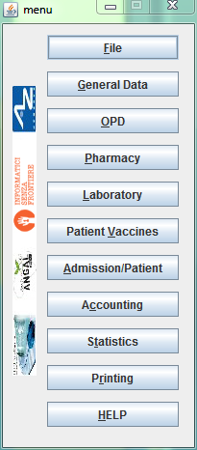

Click with the mouse on the button or digit “Alt+P” to enter the **Pharmacy** function

* Each screen of the application is called “window”. Most complex windows of the application are composed by more than one area. Areas can be **Selection panel**, **Data table** and **Buttons panel** (see ***Laboratory browsing*** window below)

Area where you can apply search criteria is called “**Selection panel**” in the entire document

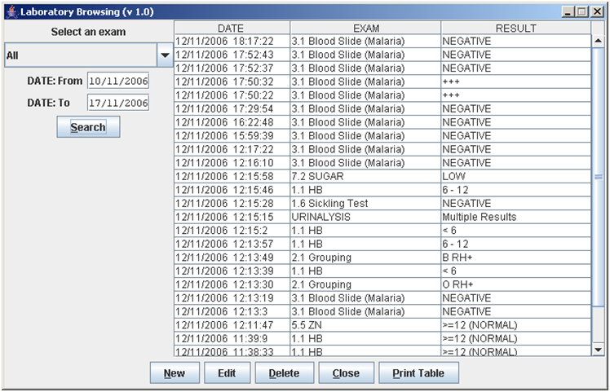

Area where data are displayed is called “**Data table”** in the entire document

Area where you can choose the functions to be applied is called “**Buttons panel**” in the entire document

***Laboratory browsing*** is the name of this window

* Highlight of a record. To highlight a record (it is a line on a **Data table**) you have to click with the mouse on the record. The record (all the line) will be highlighted in blue. This is valid all over the application (see example below):

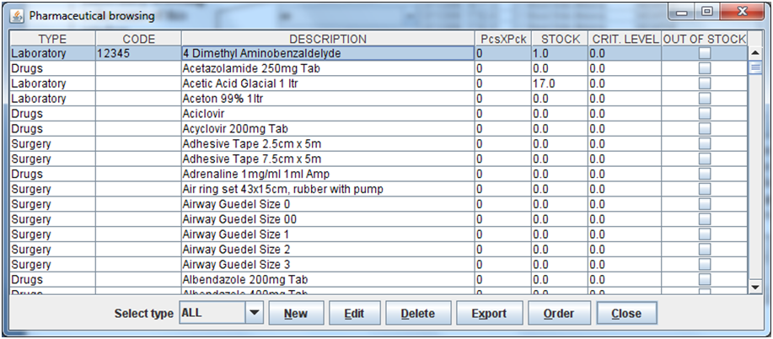

Record (line) highlighted

# Run the application

After double-clicking the program icon  on your desktop, you will see an information image (splash image) for a few seconds and then the main *menu* of the OpenHospital application will appear.

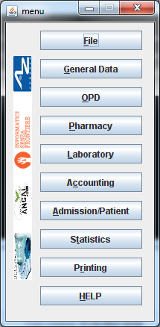

From a menu you can get to another menu of deeper level, as in the example below. From the main ***menu*** you get the ***General data*** menu, or you can directly go in a function of the application (see the following example with the browser ***OPD Out Patient Department***.

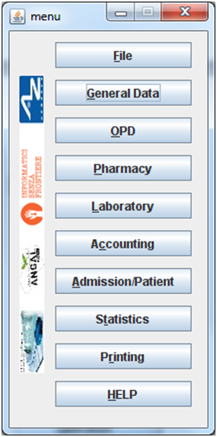

Clicking on

**General data** on the main ***menu*** on the left you access the **General *data*** menu showed on the right

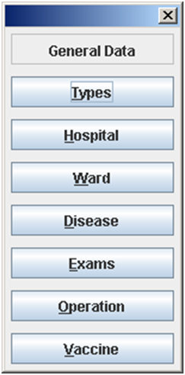

or you can directly go in a function of the application, as following example:

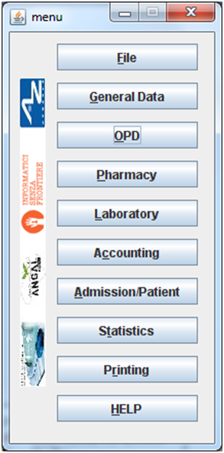

Clicking on

**OPD** on the main ***menu*** you access directly the

***OPD Out Patient Department*** windowshowed below

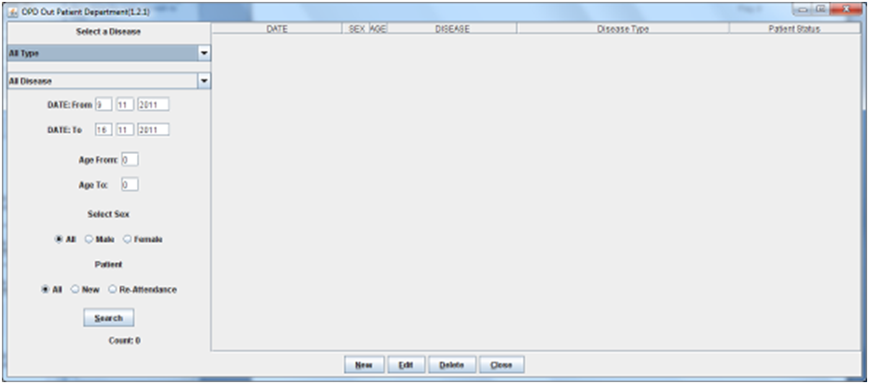

# Outpatient Department Management (OPD)

## Main Characteristics

Out Patient Department functionalities allow to record Ambulatory Patient visits, search, review, edit and eventually delete visits, and allows queries necessary for statistical purposes.

Click on **OPD** button or press “Alt + O” in the main ***menu*** to access OPD function.

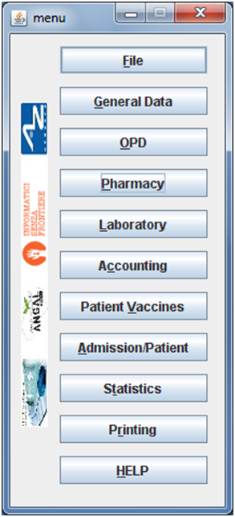

Press **OPD** button or “ALT +O”

## Functions of Out Patient Department

All functions available under **OPD** are accessible from thewindow ***OPD Out Patient Department*** showed below.

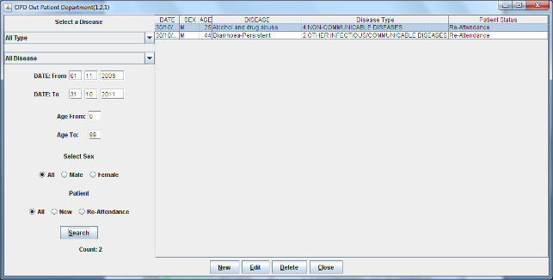

The following functions are available from the **Buttons Panel** ofthe window ***OPD Out Patient Department*:**

* **New** to create a new patient visit
* **Edit** to modify an already stored patient visit
* **Delete** to delete a patient visit
* **Close** to exit from the function ***OPD Out Patient Department***

Furthermore a search function (**Search**) is available using the **Selection Panel** on the left of the window.

### Search patient visits (Search)

Queries about Ambulatory Patient Visits can be done using the search criteria available on the **Selection Panel** area of the window (left side of the window).

Doing the selection, data about patients can be selected by choosing specific fields among the following ones:

* **Disease type.** You can select one or all disease types
* **Disease.** You can select one or all the diseases
* **Date. “**DATE From” and “DATE To” allow the selection of all the visits performed over the requested period
* **Age. “**Age From” and “Age To” allow the selection of all the patients by age
* **Sex.** Allow the selection of all the patients by sex: All / Male / Female
* **Type of patient.** Allow the selection of all the visits by attendance: All / New / Re-Attendance
* **Count.** Counter at the bottom counts for you how many visits match your criteria after pressing the **Search** button.

After having chosen press **Search** button. The system will show on the **Data table** area results of the search applying criteria requested by you.

In the example hereinafter all the visits of patients with Asthma disease admitted in the period from 2006-11-01 until 2006-11-15 of all the ages, all sex, all patient type are showed.

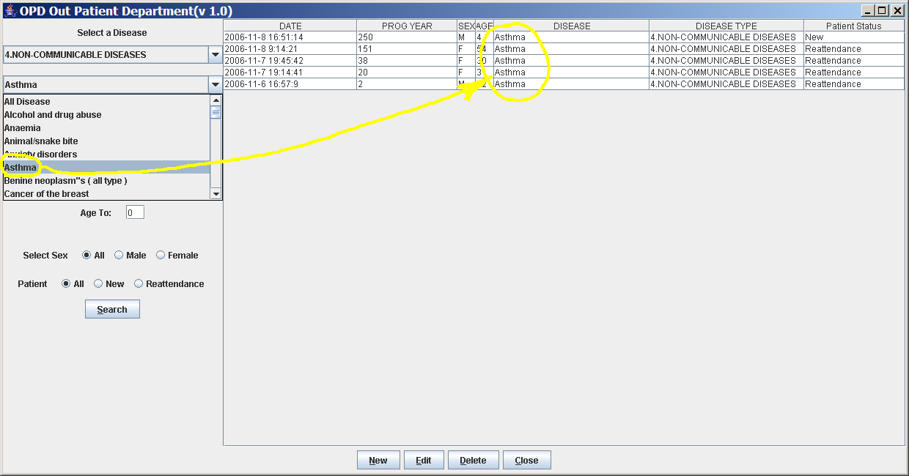

### Create a new patient visit (New)

Press **New** button in the ***OPD Out Patient Department*** window to access the ***New OPD registration*** window showed below.

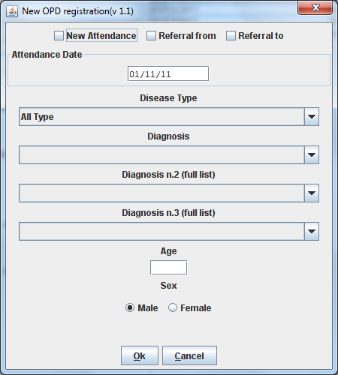

To record a visit, enter the following fields:

* **Type of attendance.** This field is not meant to distinguish whether an individual is new or not in the ambulatory (absolutely first time he/she enters the ambulatory). The NEW ATTENDANCE is devoted to cases when Patient (at his first or n-th time in the ambulatory it does not care here) comes to the Ambulatory to report a new health issue / new disease for which no care has already been addressed and recorded. The re-attendance is – on the contrary – the case of records created when a Patient comes back to the Ambulatory in order to follow-up a past new attendance when he/she received cares and previous instructions to recover.  *Example: a Patient comes to the ambulatory because he/she reports a cut ==> this event is recorded as NEW ATTENDANCE and Doctor sutures the wound and invites Patient to come back ten days later; then same patient comes back after ten days to have his/her stitches removed: a new OPD record is then created but with no NEW ATTENDANCE flag set.*
* **Date of the visit**. Date in which Patient is met for recorded activity.
* **Disease Type:** By selecting a *DiseaseType* the first diagnosis list will contains only its related diseases. Second and third list will still contain all diseases.  
    
  ***NB****: Disease Types can be defined by the Administrator.* *Ask to your Administrator how to do it or see* [*General Data*](#_General_Data_(General) *in this document.*
* **Diagnosis.** Maximum three diseases can be diagnosed per each attendance (“new attendance” or “re-attendance” it does not care in this context). Normally patient reports at least one visit reason but it may happen that during same visit the Doctor finds other concurrent pathologies thus here possibility is given to record till maximum three (the first being the only one mandatory).  
    
  ***NB****: in the* ***OPD Out Patient Department*** *window only first diagnosis and its type will be show, anyway all data are stored and processed in reports and searching.*
* **Patient age**. Validity range is 0-200.
* **Patient sex**. Male/female

When you finish entering data in the **Buttons Panel** you have the following choices:

* **Ok** to confirm and record patient visits
* **Cancel** to close the window and to return to the Menu

### Modify a recorded patient visit (Edit)

First of all to modify a visit you have to highlight it in the ***OPD Out Patient Department*** window. Once you’ve done this, press the **Edit** button. When the ***Edit OPD registration*** window showed below appears, the record is available for changes. All data can be changed.

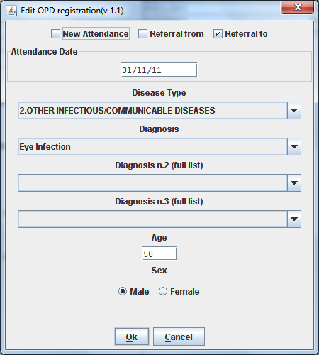

When you finish entering data in the **Buttons Panel** you have the following choices:

* **Ok** to confirm new values (all the previous values will be lost)
* **Cancel** to close the window and to return to the ***OPD Out Patient Department*** window without applying any change.

### Delete a recorded patient visit (Delete)

First of all to delete a stored visit you have to highlight it in the ***OPD Out Patient Department*** window. Secondly press the **Delete** button. The highlighted record will be showed as in the ***New Hospital*** window below. Now the record can be deleted. Deleted records won’t be available anymore.

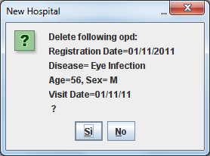

In the **Buttons Panel** you have the following choices:

* **Si** to confirm the record deletion
* **No** to close the window and return to the previous window without delete the record

## OPD Extended (OPD v1.3)

Since OpenHospital version 1.3.1 you can extend the OPD functionality by changing the *OPDEXTENDED* flag in the configuration file. Ask to your Administrator how to do it or read the *Administrator’s Guide*.

### New features

Press **New** button in the ***OPD Out Patient Department*** window to access the ***New OPD registration (1.3)*** window showed below.

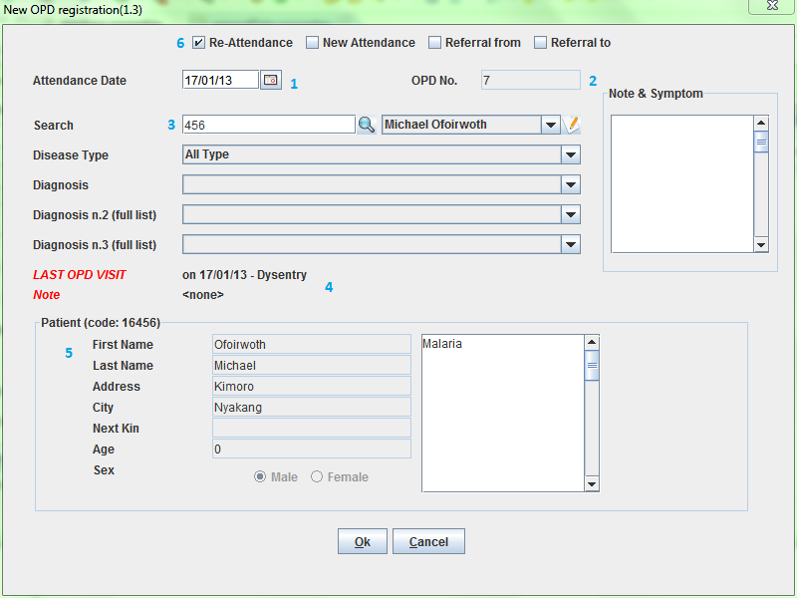

The OPD Extended module affords the following improvements:

* Calendar to choose the visit date (1);
* OPD number now is visible for tracking (2);
* Registered Patient (3): before to choose a disease you MUST select a patient first from the drop-down list; you can even fast search the patient with the search field nearby by typing part of its name or code; this will improve reliability for reports and statistics, thus service to the patients by knowing his/her history.
* one time the patient is selected and previous OPD visit is found from the program, special fields will be populated with the most recent visit of the patient (4), thus his/her personal data (5), re-attendance checkbox will be selected automatically (6);
* in case you want to insert a new attendance for this patient you can check the "new attendance" check box on and proceed normally;
* in case of editing an old OPD it is possible to change everything except the patient, which the OPD refers to, and the "new-attendance" check box;
* in case the selected patient needs to update his/her personal data, you can do it by clicking on the Edit icon  near his/her name; a new window will appears with the patient personal information to let you change them;
* in case the patient is not yet registered, the ***<new patient>*** entry can be selected to let you register the new patient; after registration you will be direct back to the OPD window and the new patient will be selected.

# Pharmacy (Pharmacy)

By pressing **Pharmacy** from the main menu you access the Pharmacy menu. From this menu you have the following functions available: **Pharmaceuticals** and **Pharmaceuticals Stock**, **Pharmaceuticals Stock Ward.**



Press **Pharmacy** button or “ALT + P”

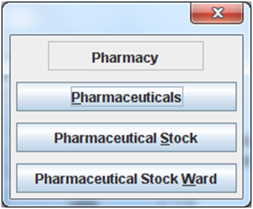

***NB:*** *Pharmaceuticals Stock Ward functionality**can be disabled**by changing the INTERNALPHARMACIES flag in the configuration file****.*** *Ask to your Administrator how to do it or read the Administrator’s Guide.*

## Pharmaceuticals (Pharmaceuticals)

### Main Characteristics

Pharmaceutical functions allow you to insert, to modify and to delete pharmaceuticals. Moreover, it provides important information about pharmaceuticals:

* the current quantity lying in the stock
* the limit quantity that defines when a pharmaceutical is going out of stock
* if the pharmaceutical is out of stock
* the expiring drugs within today or a period

Note: in OpenHospital to identify pharmaceuticals sometimes is used the word “pharmaceutical” and in others the synonymous “Medical”.

### Functions of pharmaceuticals

To access the functions of Pharmaceuticals press **Pharmaceuticals** on the Pharmacy menu.

All functions available under Pharmaceuticals are accessible from the ***Pharmaceutical browsing window*** showed below. It displays all the pharmaceuticals available in the hospital.

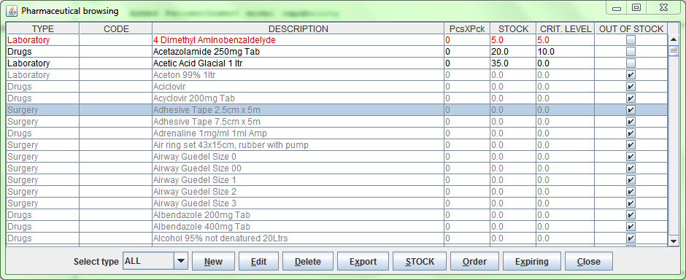

If the pharmaceutical quantity is under the critical level it will be shown in RED.

If the pharmaceutical quantity is zero it will be shown in GRAY and the square in the last column will be checked.

The following functions are accessible from the **Buttons Panel** ofthe ***Pharmaceutical browsing*** window:

* **New** to register a new pharmaceutical
* **Edit** to modify an already registered pharmaceutical.
* **Delete** to delete a pharmaceutical.
* **Export** to export the pharmaceuticals to a CSV file (Excel)
* **STOCK** to show the report of stock quantities
* **Order** to show the list of pharmaceuticals that have to be ordered.
* **Expiring** to show the list of pharmaceuticals that are going to expire
* **Close** to exit from the **Pharmaceuticals browsing**

On the left a particular combo box is placed. According to its selection, the table will display pharmaceutical of a specific type. By default it's selected on the ALL option.

#### Insert a new pharmaceutical (New)

Press **New** button in the ***Pharmaceutical browsing*** window to access the ***New medical record*** window showed below.

To insert a new pharmaceutical enter the following fields:

* **Type** (for instance, Drugs or Chemical)  
    
  ***NB****: Types can be defined by the Administrator.* *Ask to your Administrator how to do it see* [*General Data*](#_General_Data_(General) *in this document*
* **Code**: code that identify univocally your pharmaceutical for fast searching
* **Description**: the description of the pharmaceutical
* **PcsXPck**: Pieces per packet (if more than 1)
* **Critical level**: the minimum quantity required in stock

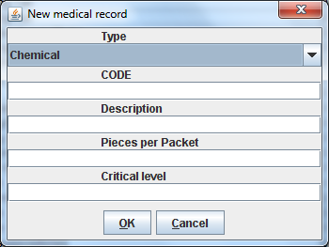

When you finish entering data in the **Buttons Panel** you have the following choices:

* **Ok** to confirm data
* **Cancel** to close the window and to return to the Menu

#### Modify an existing pharmaceutical (Edit)

Press **Edit** button in the ***Pharmaceutical browsing*** window to access the ***Editing medical record*** window showed below. You can modify all data unless “Type”

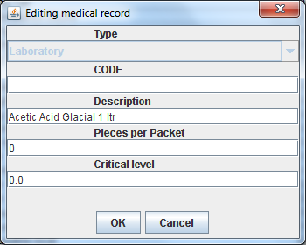

When you finish entering data in the **Buttons Panel** you have the following choices:

* **Ok** to confirm data
* **Cancel** to close the window and to return to the Menu

#### Delete a pharmaceutical (Delete)

In order to delete a pharmaceutical you have to highlight it before. Secondly press the **Delete** button. ***The New Hospital window*** appears.

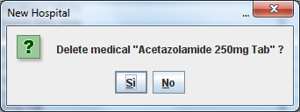

In the **Buttons Panel** you have the following choices:

* **Si** to confirm the record deletion
* **No** to close the window and return to the previous window without deleting the record

#### Export the list of pharmaceuticals (Export)

Use this function to export on excel the list of pharmaceuticals showed in the ***Pharmaceutical browsing*** window.

Press **Export** button in the ***Pharmaceutical browsing*** window to access the ***Save*** window showed below. It will be in the language of your computer, no matter the language used in OpenHospital.

Then you can start the export of the list of pharmaceuticals.

In the ***Save*** window you have to:

* select the directory of your file system where you want to store the file
* input the name you want to give to the file (Filename)

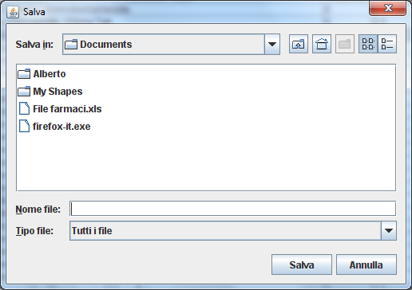

#### Stock report (STOCK)

Press **STOCK** button in the ***Pharmaceutical browsing*** window to produce the report of pharmaceuticals in the stock grouped by *IN STOCK* and *OUT OF STOCK*.

#### Order of pharmaceuticals (Order)

Press **Order** button in the ***Pharmaceutical browsing*** window to produce the list of pharmaceuticals remaining in stock and the ones to be reordered according with their critical level.

#### Order of pharmaceuticals (Expiring)

Press **Expiring** button in the ***Pharmaceutical browsing*** window to produce the list of pharmaceuticals that are going to expire grouped by type and lot.

## Pharmaceutical Stock (Pharmaceutical Stock)

### Main Characteristics

The Pharmaceutical Stock feature helps you to store and trace every stock movement that has been made. Every movement is identified by the following data:

* date of the movement
* type of the movement, that is, if it’s a charging or discharging one
* the ward that the movement refers to. This characteristic is needed for discharging movements only. In fact, it’s important to know in which ward pharmaceuticals have been used, otherwise this field will appears empty
* the quantity
* the pharmaceutical (which in turn relates to different categories: Laboratory, Surgery, Drugs or Chemical)
* the lot which the movement is referred to. Actually, there are some pharmaceuticals that may not have a lot related (for example ‘Gloves’), so you can omit this field. But it’s recommended to store even the lot (if it exists), because every lot has its own peculiarity:
  + a name (that can be its code)
  + a preparation date
  + a due date

In this way you can find which movement refers to the pharmaceuticals that are expiring, or pharmaceuticals prepared in a specific date, or how many movements have been registered about that lot, and so on.

* the origin of the pharmaceutical. This characteristic is needed for charging movements only. This field will appears empty in other cases

### Functions of Pharmaceuticals Stock

To access the functions of Pharmaceuticals press **Pharmaceutical Stock** on the Pharmacy menu showed below.

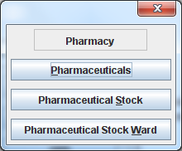

The window ***Stock movement browser*** showed below will be opened. All functions available under Pharmaceutical Stock are accessible from the ***Stock movement browser*** window.

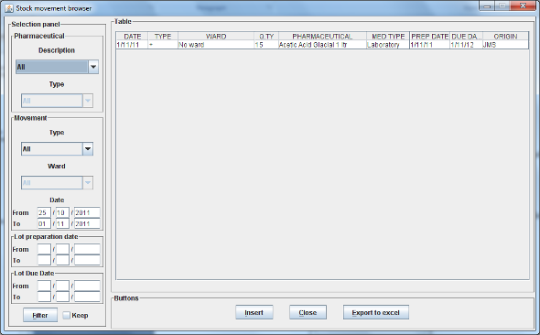

The following functions are available from the **Buttons Panel** ofthe window ***Stock movement browser*:**

* **Insert** you use it to record a new stock movement
* **Close** button, to exit from the ***Stock Movement Browser*** window
* **Export to excel** to export pharmaceuticals stock movements

As you can see, there’s no “Delete” button as you’re not allowed to delete a movement; but, if a mistake occurs - for example you’ve inserted the wrong quantity of a pharmaceutical in charge – you must just insert the new movement to correct the mistake – a discharge movement in this example.

Furthermore a search function (**Filter)** is available using the Selection panel on the left of the window.

#### Search pharmaceuticals stock movements (Filter)

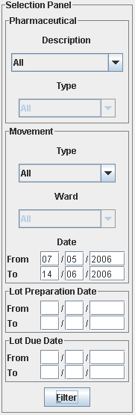

Using ***Stock Movement Browser*** search function you can filter and show on the window useful information such as:

* how many boxes of pharmaceutical remains in the stock
* which movements have been made in a specific day
* in which ward a specific pharmaceutical has been discharged
* if there are any pharmaceutical expired

Queries about movements of pharmaceuticals can be done using the search criteria available on the **Selecion panel** area of the ***Stock movement browser*** window (left side of the browser). Results of your search are showed on the **Data table** area.

The selection panel is used to select a group of movements according to specific filters. You set a filter using the tools contained in the selection panel.

Filters refer to three different objects: the **Pharmaceutical**, the **Movement**, and the **Lot preparation and Lot due date**.

As far as a **Pharmaceutical** is concerned, user can choose its:

* description, that is its name
* type: Laboratory, Surgery, Chemical and Drugs

In order to avoid conflicts, you can change one of these options only. So, when the description combo box is active, the other one is not, and vice versa.

As far as **Movement** are concerned, user can choose its:

* ***Type***: it specifies if it’s a charge or a discharge one. If you select the discharge option, then the ward combo box gets enabled. The ward combo box allows you to find any discharging movements that refer to a specific ward.
* ***Date***: you can choose a time frame between ‘Date from’ and ‘Data to’. The date tools consist of three blank areas, which (from left to right) refer to day, month and year. As you have inserted a value on a blank area, he can move to the next one by typing the “Tab” button on the keyboard. As the window is loaded, the date is set in such a way to cover the last week by default.

Finally, as far as **Lot preparation** and **Lot due date** you can search movements that refer to specific lots by inserting:

* the lot preparation date: you have to choose a valid time span (between ‘Preparation Date From’ and ‘Preparation Date To’)
* the due date; it behaves like the lot preparation tool and the movement date tool.

Each filter can be combined with another, allowing you to obtain many possibilities.

After having chosen press **Filter** button. The system will show on the **Data table** area results of the search applying criteria requested by you.

#### Insert stock movement (Insert)

To insert stock movements you have to Press **Insert** in the ***Stock movement browser*** window. The ***Stock movement inserting*** window showed below appears. You can enter charge or discharge movements.

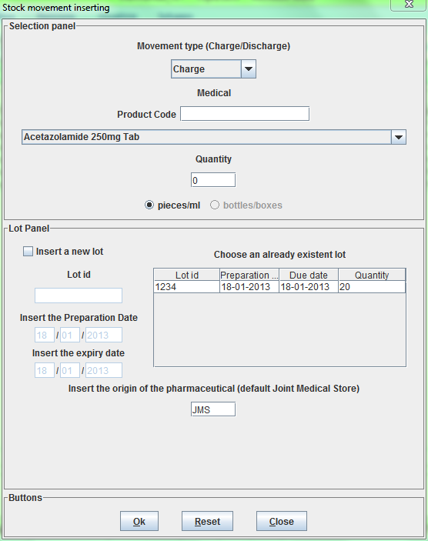 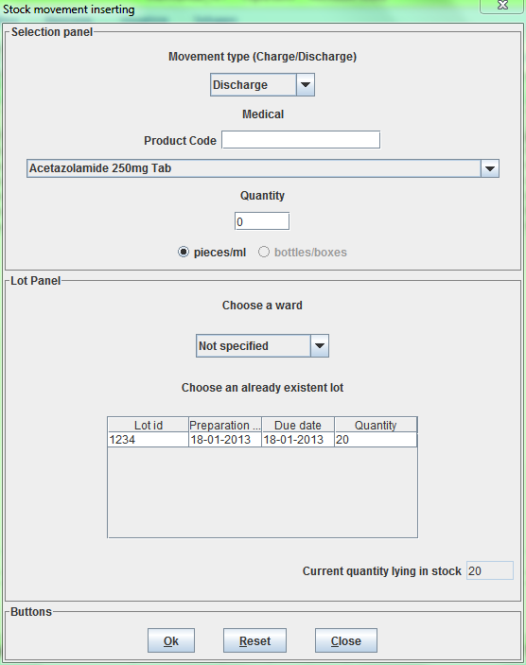

A movement performs a charge or a discharge of a quantity of a pharmaceutical. The window is composed by three areas: a **Selection panel** to identify the pharmaceuticals and enter the quantity, the **Lot Panel** area that will be different based on the type the movement and the **buttons panel** area.

##### Charging

If you have to enter a charge movement, then you have to input the following fields in the ***Stock Movement Inserting*** window:

* **Movement Type**: charge
* **Medical**: you can enter the code of the pharmaceutical (medical) if known, otherwise you have to select a pharmaceutical (medical) using the mouse
* **Quantity**: the quantity of pharmaceutical you want to store. If PiecesPerPacket has been defined for selected pharmaceutical you can decide if insert pieces or packet. The amount will be automatically converted in pieces  
    
  ***NB****: at the bottom of the* ***Stock Movement Inserting*** *window you will read the Current Quantity Lying in Stock for the selected pharmaceutical. If with this movement you’re going under the critical level for the selected pharmaceutical a confirmation pop-up window will appears to let you confirm the discharging operation.*
* **Lot:** you may select an existing lot where to charge the selected pharmaceutical into or create a new lot by specifying a **LotId**, the **PreparationDate** and the **ExpiringDate**. This will help you in the future to identify which drugs are going to expiry.
* **Origin of the pharmaceutical**: description of 30 characters (field not mandatory)

***NB****: The Lot definition can be set as automatic by changing the flag AUTOMATICALOT* *in configuration file, so every new charging movement will automatically create a new lot; anyway PreparationDate and ExpiringDate must always be provided.* *Ask to your Administrator how to do it or read the Administrator’s Guide.*

##### Discharging

If you have to enter a discharge movement then you have to input the following fields:

* **Movement Type**: discharge
* **Medical**: you can enter the code of the pharmaceutical (medical) if known, otherwise you have to select a pharmaceutical (medical) using the mouse
* **Quantity**: the quantity of pharmaceutical you want to discharge in pieces
* **Ward**: the ward that requires the pharmaceutical (if not known let “not specified”)
* **Lot**: the lot you want withdraw from. If the amount you want to discharge is greater than any lot listed below you must split the movement.

***NB****: If AUTOMATICALOT* *in configuration file is set to* ***true****, you’ll find all lots automatically created by the application with an automatically generated random ID.*

When you finish entering data in the **Buttons Panel** you have the following choices:

* **Ok** to confirm and store the movement
* **Reset** to delete the fields on the window and restart the input
* **Close** to close the window and return to the ***Stock movement browser*** window without inserting the movement

##### Other Movement Types

The Administrator can define more Movement Types as “donation”, “rectifying”, “inventory”, etc... as a different type of charging (+) or discharging (-) movement. Ask to your Administrator how to do it or see [General Data](#_General_Data_(General) in this document.

## Pharmaceuticals Stock Ward (Pharmaceuticals Stock Ward)

### Main Characteristics

The Pharmaceutical Stock Ward feature allows the management of the pharmacy at ward level.

**Pharmaceuticals Stock Ward** functionalitycan be enabled or disabledby changing the *INTERNALPHARMACIES* flag in the configuration file**.** Ask to your Administrator how to do it or read the *Administrator’s Guide*.



### Functions of Pharmaceuticals Stock Ward

To access the functions of Pharmaceuticals press **Pharmaceutical Stock Ward** on the Pharmacy menu showed below.

The window ***Ward pharmacy*** showed below will be opened. All functions available under Pharmaceutical Stock are accessible from the ***Ward pharmacy*** window selecting one **WARD** on the top left of the window.

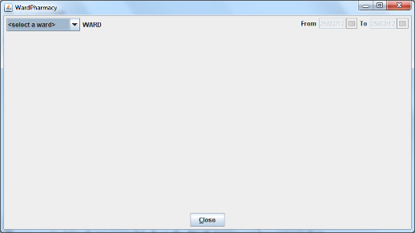

After the selection of the ward (INTERNAL MEDICINE in the example) the ***Ward pharmacy*** window appears as showed below and you can start the management of the ward pharmacy of the INTERNAL MEDICINE ward.

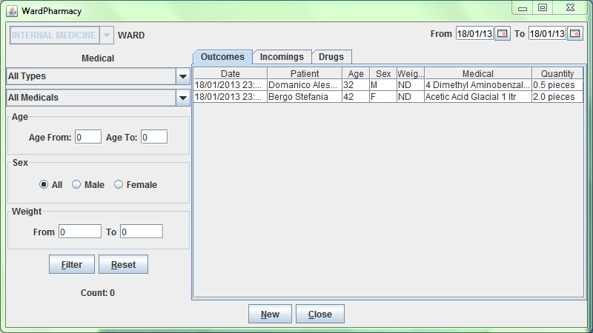

Differently by **Pharmaceuticals Stock** functionality, the **Pharmaceutical Stock Ward** allows only discharging movements to patients since is an internal management of pharmaceuticals lying in the wards after they have been “charged” by the main pharmacy.

The ***Ward Pharmacy*** window will show a **Filter Panel** on the left, a **Movements Panel** in the right-centre and a **Button Panel** at the bottom.

#### Search Ward Pharmacy movements (Filter)

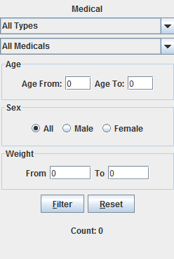

The **Filter Panel** allows you to filter registered movement by:

* Medical
* Age
* Sex
* Weight

The counter at the bottom will automatically count how many movements’ matches your filtering criteria after clicking the **Filter** button.

A **Reset** button will bring back all values in the Filter Panel as in the figure shown.

#### The Movements Panel

The Movements Panel is made by three tabs:

* **Outcomes**: shows all the movements registered between the dates in **From** and **To** fields in the top of the window. By default **From** and **To** dates are set on the date of today. Every movement is identified by following fields:
  + **Date**: the date of the movement
  + **Patient:** the patient the movement is related to, with his/her age, sex and weight (ND if the weight has not been defined at the registration moment)
  + **Medical**: the drug subject of the movement
  + **Quantity**: the quantity subject of the movement
* **Incomes**: shows all incomings from the main pharmacy, it’s to say all discharging movements registered in ***Pharmaceutical Stock*** window related to selected ward
* **Drugs**: the amount of drugs remaining in the selected ward as a result of all incoming minus all out comings.

#### Inserting a new Ward Pharmacy Movement (New)

To insert ward pharmacy movements you have to press New in the ***Ward Pharmacy*** window. The ***New / Edit*** window showed below appears.

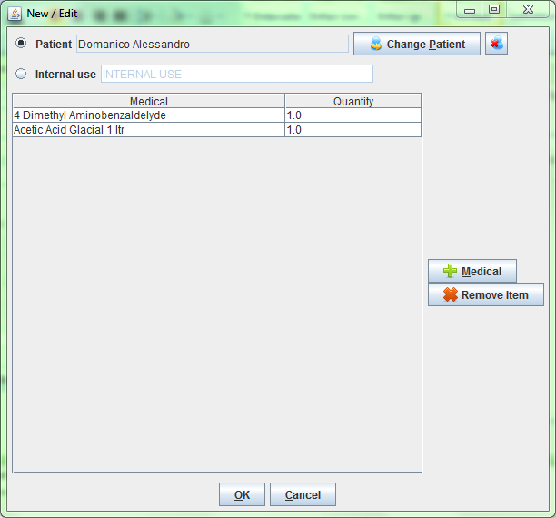

As told before, only discharging movements are allowed in this functionality. So the solely informations required are the follow:

* **Patient** or **Internal Use**: you may select an already registered patient by clicking on **Pick Patient** button so the movement will be associated to his/her ID or select **Internal Use** and type a description to specify that the movement is not related to a patient.
* **Medicals**: by pressing **Medical** button you will be asked for the drug to give to that patient; a first window will appear to let you select the drug (the only ones you may have in the ward as an result of a previous discharging movement in the ***Pharmaceutical Stock Browser***) and a second one to let you specify the quantity; multiply of half-piece are allowed.

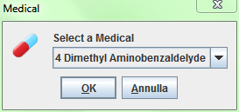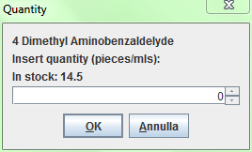

Before to press the **OK** button you may insert as many Medicals you need, it will show a correspondent number of movements in the **Outcomes** tab of the **Movement Panel** in the ***Ward Pharmacy*** window.

# Laboratory (Laboratory)

## Main Characteristics

With Laboratory’s features the user can manage the laboratory exams.



Press **OPD** button or “ALT + L”

It is possible to create, modify or delete exams.

* Insert a new Laboratory exam
* Delete (or edit) an existing exam
* Select some exams with the Filter Button (user can select the exam’s name, the exam’s result and the date between the exam was made)

## Functions of Laboratory

To access the Laboratory’s functions press **Laboratory** on the main menu of OpenHospital. The ***Laboratory browsing*** window appears.

All functions available under **Laboratory** are accessible from the ***Laboratory browsing*** window showed below. By default the system shows all the laboratory exams recorded.

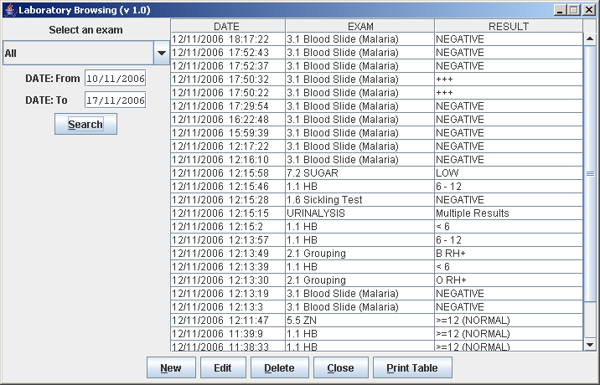

Data that identify laboratory exams are the following:

* **Date**: indicates date and time when the exam was entered
* **Exam:** description of the exam
* **Result**: result of the exam

To access the other functions of laboratory in the **Buttons Panel** you have the following choices:

* **New** to enter a new laboratory exam
* **Edit** to modify an existing laboratory exam
* **Delete**, to delete an existing laboratory exam
* **Close** to close the window and return to the Menu
* **Print table** to print the list of laboratory exams showed in the table

Furthermore a search function (**Search)** is available using the Selection panel on the left of the window.

### Search of Laboratory exams (Search)

Search function allows you to select and show laboratory exams on the **Data table** of the ***Laboratory browsing*** window.

In the example hereinafter all types of exams executed from 10.11.2006 until 17.11.2006 are showed in **Data table**.



Data about exams can be selected by choosing specific fields among the following:

* **Select an exam:** Values admitted are:

ALL, exams of all types are showed

Single exam, only the exams of the selected type are showed

* **Date: “**DATE From” and “DATE To” allow the selection of all the exam executed in the requested period

After the selection press **Search** button; the system will show on the table results of the search applying the criteria requested.

### Create a new laboratory exam (New)

Press **New** button in the ***Laboratory browsing*** window: The ***New Laboratory exam*** window showed below appears:

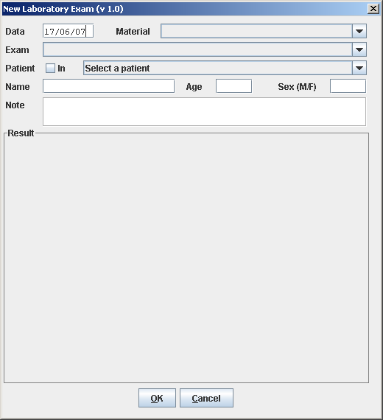

To record the visit enter the following fields:

* **Data**: date of the exam, the application propose the current date
* **Material**: choose from the available values the material used in the exam
* **Exam**: choose the exam
* **Patient in**: it activates itself if the selected patient is currently admitted, anyway is possible to change it if needed.
* **Select a patient**: you select the patient that does the exam. The field is not mandatory and therefore you can input an exam by typing patient’s information in the following fields.
* **Name**: First and last name of the patient *(automatically filled if a patient is selected)*
* **Age**: age of the patient (range 0-200) *(automatically filled if a patient is selected)*
* **Sex**: value M for male, value F for female *(automatically filled if a patient is selected)*
* **Note**: free description
* **Result**: according with the chosen exam you will see in this panel a range of available results to select.

#### Results

In OpenHospital you have basically two kind of possible results for each exam:

* **Single Result**: where you can select only one result among a list
* **Multiple Results**: where you may specify many results among a list of positive/negative values

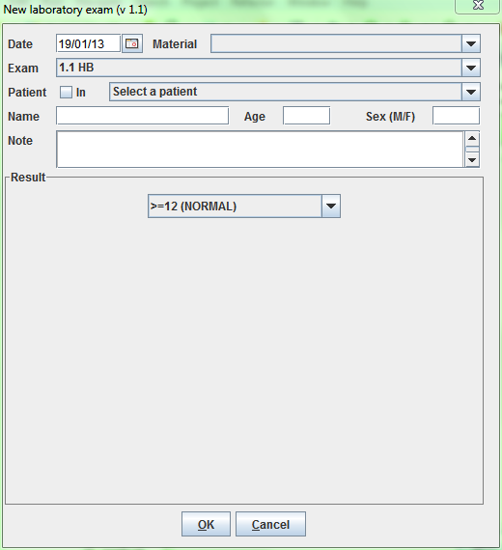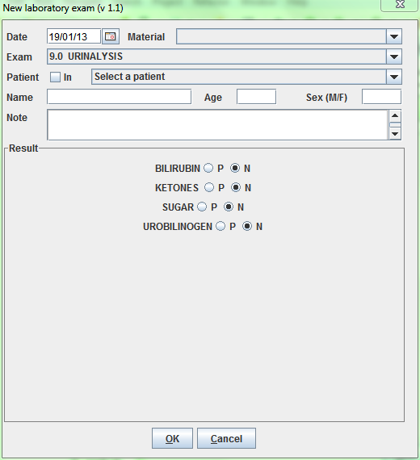

***NB****: Exams, ExamTypes and Results as well, can be defined by the Administrator.* *Ask to your Administrator how to do it or see* [*General Data*](#_General_Data_(General) *in this document.*

When you finish entering data in the **Buttons Panel** you have the following choices:

* **Ok** to confirm and record data
* **Cancel** to close the window and return to the Menu without record data

### Modify a laboratory exam (Edit)

To modify an exam you have to highlight it first in the ***Laboratory browsing*** window. Once highlighted, press **Edit** button to enter the ***Edit Laboratory*** exam window showed below. Now the record is available for changes. With this function you can modify all data of the exam and you can input the result of the exam too.

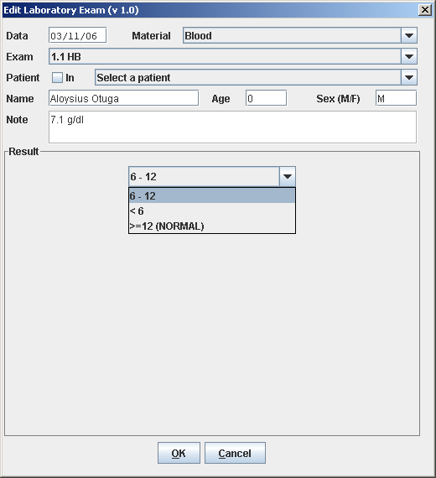

### Delete Laboratory Exam (Delete)

To delete an exam you have to highlight it first in the ***Laboratory browsing*** window. Once highlighted, press **Delete** button to see the confirmationwindow showed below.

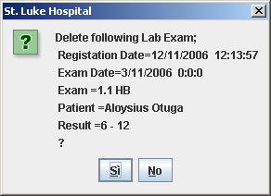

## Laboratory Extended (v.1.1)

Since OpenHospital version 1.3.1 you can extend the *New Laboratory* functionality by change the *LABEXTENDED* flag in the configuration file. Ask to your Administrator how to do it.

### New Laboratory Browsing (v 1.1.)

The new window will appear like the following:

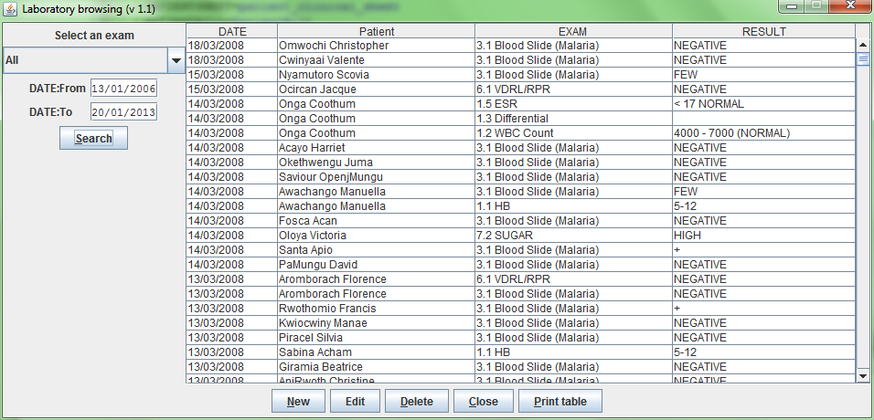

The only difference is the new column about the name of the patient for a fast research.

### New Laboratory Exam (v. 2.0)

The new ***Laboratory Exam*** window is now strictly related to the patient, it’s to say that the exam must be assigned to a patient previously registered in the DB.

Before to close the window with the exam result you must have selected a patient from the list; the fields below will give you a slight patient details summary.

A search field can be used to fast search the patient by typing part of his/her name or his/her OpenHospital code (which is specified in the Patient window, see ***Patient Extended***).

The New Laboratory Exam window (thus the Edit one) will appear like the following:

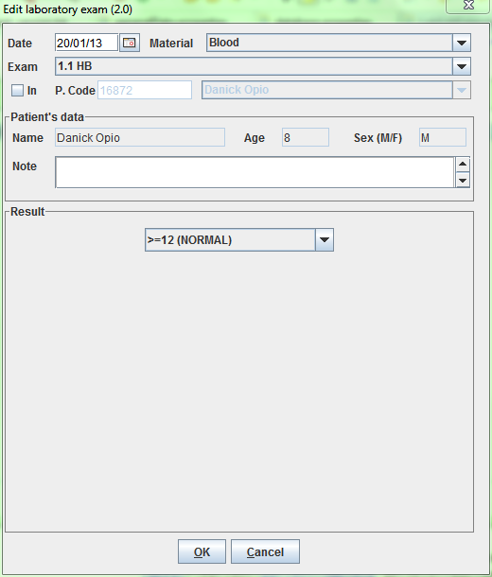

The **Patient’s data panel** cannot be modified except **Note Field** and only shows the information related to the selected Patient.

### Laboratory Multiple Insert

Since OpenHospital version 1.4.1 you can extend the *New Laboratory* functionality by change the *LABMULTIPLEINSERT* flag in the configuration file. The flag *LABEXTENDED* have to be enabled too. Ask to your Administrator how to do it.

The New Laboratory Multiple allows multiple exam insertion for each patient, avoiding repeating the new laboratory exam procedure (**New**) for every exam for the same patient.

#### New Patient Exam (New)

Press **New** button in the ***Laboratory browsing*** window: The ***New Patient exam*** window showed below appears.

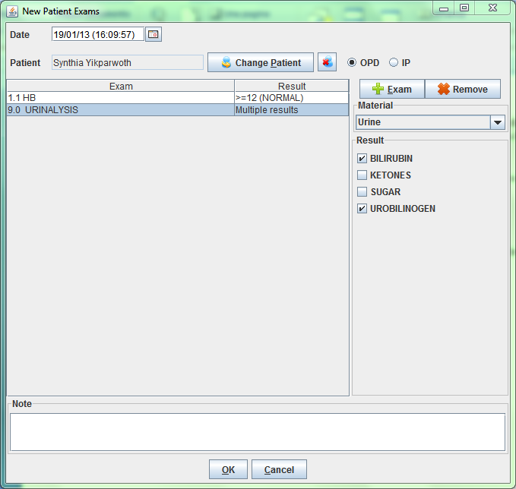

To record the visit enter the following fields:

* **Data**: date of the exam, the application propose the current date
* **Patient**: select a patient by pressing the **Find Patient** button
* **OPD/IPD**: the window automatically will check if the patient is admitted or not in the hospital; anyway is possible to change it if needed
* **Exam**: choose the exam; a first window will ask you the material, then a second one the exam, finally a third one will ask you the result is the exam allow only a single result, otherwise the list of multiple results will be showed on the right, together with the chosen material.
* **Note**: free description for each exam

***NB****: At anytime, before to press OK, you can modify every exam by clicking it on the list and changing material, results and note in the relative panels.*

# Accounting (Accounting)

## Main Characteristics

Accounting is the function that you have to use to manage the billing process. You can enter the bill of pharmaceuticals, operations, exams or other costs of a patient. For the time being the billing process is not linked with other functions of  **OpenHospital** and therefore the application do not propose the billing item based on the therapy followed by the patient: the user has to input all the items.

Accounting function furthermore allows to manage the payment of bills (total or partial) and to produce reports.



Click here or digit “A+C” to enter in the ***Accounting*** menu showed below

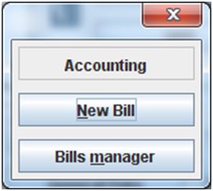

## Functions of Accounting

All functions available under **Accounting** are accessible from the ***Patients Bills Management*** windowshowed below. To access the ***Patients bills Management*** window press **Bills Manager** on the ***Accounting*** menu.

By default the window shows in the **Data table** all the bills of today (current day).

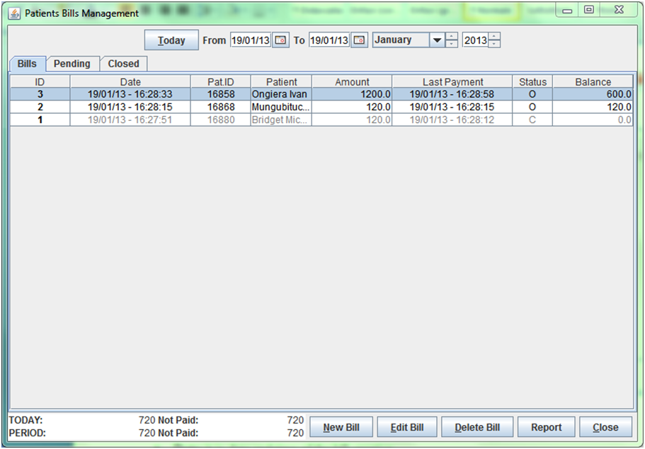

The application shows in the **Data table** all the bills of the period that you select here; in this example from 1.11.11 until 03.12.11

The application shows in the bottom panel the **Incomes Table** with the amounts **PAID** and **NOT PAID** within **TODAY** and within the visualized **PERIOD**

For each bill the following data are shown on **Data table:**

* **ID:** it is the number of the bill (created automatically by the application)
* **Date:** it is date and time of the bill creation
* **Pat ID:** it is the patient ID (created automatically by the application at the registration time)
* **Patient:** it is thepatient name
* **Amount:** it is the total amount of the bill
* **Last payment:** it is date and time of the last payment
* **Status:** it is the status of the bill; values are: ”O” (open) if not fully paid; ”C” (closed) if fully paid
* **Balance:** it is the bill amount not paid yet

The following functions are accessible from the **Buttons Panel** ofthe ***Patients Bills Management*** window**:**

* **Today** (button on top of the window) to show on **Data table** only the bills of the current day
* **New Bill** to insert a new bill
* **Edit Bill** to modify an already stored bill if its status is “O” (Open)
* **Delete Bill** to delete an already stored bill
* **Report** to print a variety of reports
* **Close** to exit from the function ***Patients Bills Management*** and return to the **Accounting** menu

Furthermore the ***Patients Bills Management*** window shows an **Incomes Table** with follow informations:

* **First Row**: the **PAID** and **UNPAID** within **Today**
* **Second Row**: the **PAID** and **UNPAID** within the visualized **Period**

### Insert a new bill (New Bill)

You can use the **New Patient Bill** function to register a new bill of a patient. Press **New Bill** button in the ***Patients Bills Management*** windowto access the ***New Patient Bill*** window showed below.

The bill is not saved until you do not confirm it with the **SAVE** function (see description below).

Before entering in the description of the function we provide you the description of the contents of the window ***New Patient Bill.***

The ***New Patient Bill*** window is composed by three areas: the **Bill Panel** on the top, the **Item Panel** in the centre, the **Payments** **Panel** on the bottom and the **Buttons panel** on the right.

Bills are composed by items. A bill item is a cost related to either a pharmaceutical or an operation or an exam or others/custom costs.

Data showed on the **Bill Panel** area are:

* **Date**: it is the date and time of the bill
* **Patient**: it is the patient associated with the bill
* **List**: it is the PriceList that will be used for this bill  
    
  ***NB****: PriceLists can be defined by the Administrator.* *Ask to your Administrator how to do it or see* [*General Data*](#_General_Data_(General) *in this document.*

Data showed on the **Item Panel** area are:

* **Item, Qty, Amount**: they are the description of the bill entry, the selected quantity and the amount; the amount is calculated as the unitary cost of the item multiplied by the quantity;
* **TOTAL**: it is the total amount of the bill  
    
  ***NB****: Prices, or unitary costs, can be defined by the Administrator.* *Ask to your Administrator how to do it or see* [*General Data*](#_General_Data_(General) *in this document.*

Data showed on **The Payments** area are:

* **Date**: it is the date and time of the payment
* **Amount**: it is the amount of the payment
* **BALANCE**: it is the not yet paid amount of the bill (difference between the Total (*) and the sum of the payments)

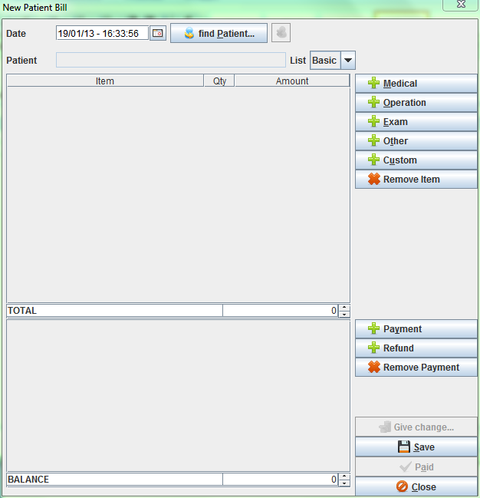

To insert a new bill first of all you have to enter the **Date field**. The application proposes you current date and time but you can modify both of them.

Then you have to select a patient. To do it, press the **find Patient** button on top of the screen. The ***Patient Selection*** windowshowed below appears.

Once you have selected the patient you can start to enter bill entries of the bill.

***NB****: If the patient has a pending bill associated it will be recalled to edit it. You cannot start a new bill for a patient before to close the previous one.*

There are several types of Bill entry. They are identified by the button on the **Buttons panel** on the right of the window; you have the following choices:

* **Medical** to enter bill entries of pharmaceuticals
* **Operation** to enter bill entries of operations
* **Exam** to enter bill entries of exams
* **Other** to enter other prices defined in the PriceList  
   ***NB****: Types can be defined by the Administrator. Ask to your Administrator how to do it or read the see* [*General Data*](#_General_Data_(General) *in this document.*
* **Custom** to enter custom items defined on the fly

#### Insert a bill entry related to Medicals, Operations or Exams (Medical, Operation, Exam)

We show here how to insert an bill entry for pharmaceutical (**Medical**); the function to insert a bill entry for operation (**Operation)** and exam (**Exam)** is the same with the only difference that for the last two is not required the quantity (the quantity is always 1).

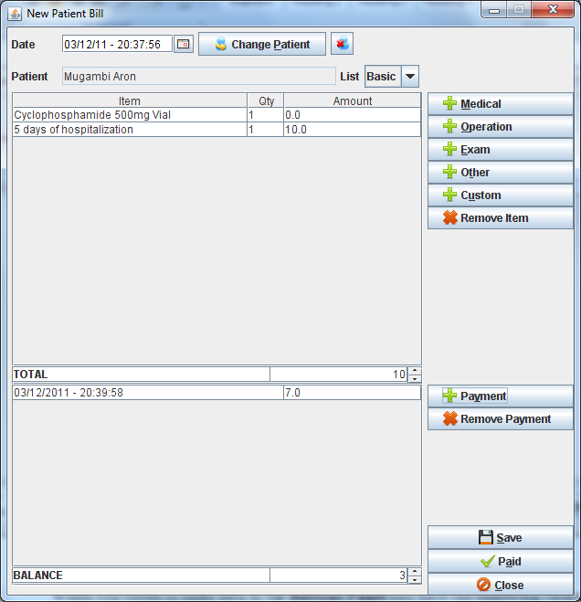

To insert a bill entry, press the **Medical** button. The ***Medical*** window showed below appears.

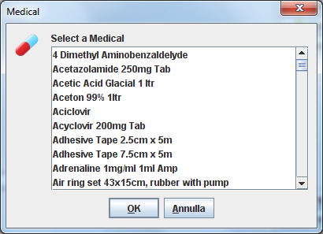

Using the mouse you have to highlight the required pharmaceutical (medical).

On the **Buttons Panel** of the ***Medical*** window you have the following choices:

* **Ok** to select the highlighted pharmaceutical
* **Annulla** to return to the ***New patient Bill*** window without selecting any pharmaceutical

If you choose **OK** the ***Quantity*** window showed below appears and you can select the quantity of pharmaceutical used by the patient.

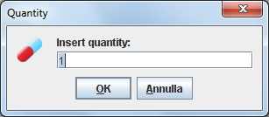

On the **Buttons Panel** of the ***Quantity*** window you have the following choices:

* **Ok** to select the highlighted pharmaceutical and return to the ***New patient Bill*** window
* **Annulla** to return to the ***New patient Bill*** window without selecting any pharmaceutical

#### Insert a bill entry related to various custom reasons (Custom)

To insert a custom bill entry you have to press the **Custom** button. The application will show the ***Custom item*** window showed below.

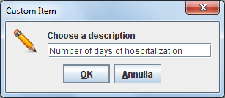

In this window you have to enter a description (in the example below is “number of days of hospitalization”) and then:

On the **Buttons Panel** of the ***Custom item*** window you have the following choices:

* **Ok** to go to the another ***Custom item*** window (to enter the quantity, see below)
* **Annulla** to return to the ***New patient Bill*** window without insert any bill entry

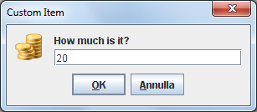

In the ***Custom item*** window you have to enter the amount related to the bill entry (in the example above is “20” in the local currency, ie. it is US dollar if the country is USA)

On the **Buttons Panel** of the ***Custom item*** window you have the following choices:

* **Ok** to confirm the bill entry and return in the ***New patient Bill*** window
* **Annulla** to return to th**e *New patient Bill*** window without insert any bill entry

#### Remove a bill entry of a bill (Remove Item)

First of all to remove a bill entry you have to highlight it on the ***New Patient Bill*** window. Once you’ve done this, (pay attention!) pressing the **Remove Item** button, the bill entry is removed. Bill entries can be removed before or after the final saving (see **Save function** described below)

#### Insert a payment (Payment)

To insert a payment you have to press the **Payment** button. The application will show the ***Quantity*** window showed below.

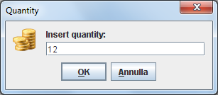

You have to insert the amount of the payment. (in the example above is “12” in the local currency, ie. it is US dollar if the country is USA)

On the **Buttons Panel** of the ***Quantity*** window you have the following choices:

* **Ok** to confirm the payment and return to the ***New patient Bill*** window
* **Annulla** to return to the ***New patient Bill*** window without insert any payment

#### Insert a refund (Refund)

Sometimes it happens that the cashier have to refund the patient; in this case you will press the **Refund** button that allow you to insert the amount to refund. It will be automatically converted in a negative addend to the payments list

#### Remove a payment (Remove Payment)

First of all to remove a payment you have to highlight it on the ***New Patient Bill*** window. Once you’ve done this, (pay attention!) pressing the **Remove Payment** button, the payment is removed.

#### Give change… (Give change…)

Sometimes it could be useful to calculate the balance to give to a patient when he/she is paying his/her bill. By pressing on **Give change...** button you will be asked the cash amount the patient is giving and automatically you will know the amount to give to him/her calculated as a difference between the patient cash and the current bill balance.

#### Save function (SAVE)

When you have completed the input of data (bill or payments) press the **SAVE** button on the button panel of the ***New Patient Bill***.

The application will save the bill and return to the ***Patients bills management*** window; the status of the bill is “O” (Open) until you will set is as PAID (**Paid**)

#### Paid function (Paid)

If the patient is going to pay his/her bill totally you can press the **Paid** button; if balance is not equal to zero it will automatically add a payment in the payments list and set this bill as “C” (Closed).

#### Print receipt function

Since OpenHospital version 1.7 you can print on the fly a receipt when you press the **Paid** button*.* To enable this feature you must enable the *RECEIPTPRINTER* flag in the configuration file and a proper device must be connected to the system. Ask to your Administrator how to do it or read the *Administrator’s Guide*.

#### Close function (Close)

Close function allows you to exit from the ***New Patient Bill*** window without saving changes done***.*** Press the **Close** button to access the Close function. The confirmationwindow showed below appears.

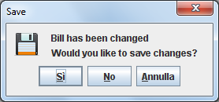

### Edit an existing bill (Edit Bill)

First of all to modify an existing bill you have to highlight it in the ***Patients Bills Management*** window. Once you’ve done this, press the **Edit Bill** button. The ***New Patient Bill*** window will appear.

***NB****: Only bills with status “O” (Open) can be modified, otherwise an A4 report will be shown.*

### Delete a bill (Delete Bill)

First of all to delete an existing bill you have to highlight it in the ***Patients Bills Management*** window. Once you’ve done this, press the **Delete Bill** button. The ***Delete*** window will appear.

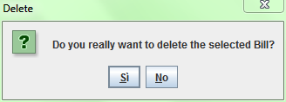

***NB****: Generally this is not allowed to regular users and should be performed only by the Administrator.*

### Reports (Report)

OpenHospital Accounting module comes with a set of reports hereby listed:

* **Today (Closure)**: report that show the current user incomes
* **Today**: report that show a statement with all paid and unpaid bills within today
* **Period**: report that show a statement with all paid and unpaid bills within the period currently visualized
* **This month**: report that show a statement with all paid and unpaid bill within the current month
* **Other month**: report that show a statement with all paid and unpaid bill within a specified month that will be suddenly asked.

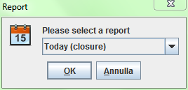

For each report, except Today (Closure), you will be asked to choose among two options:

* **Short Report (only BadDebts bills)**: report that show a statement with only the unpaid bills and the total for the others
* **Full Report (all bills)**: report that show a statement with all paid and unpaid bills

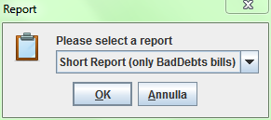

Once the choice has been done, after some instants the JasperViewer® will show the generated report as follow:

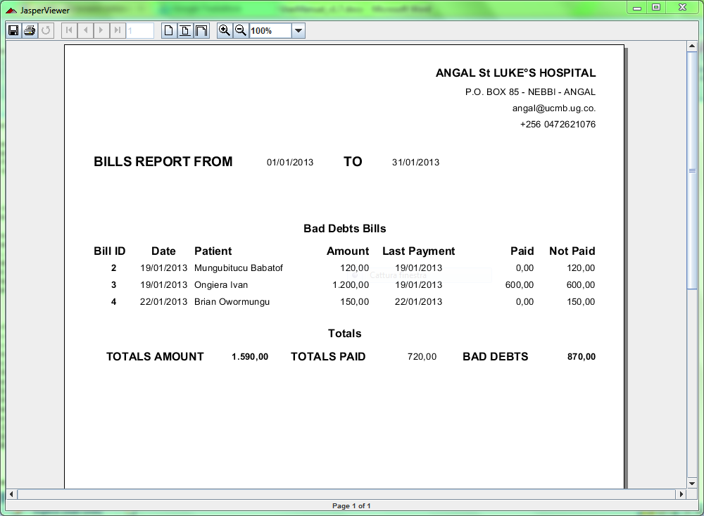

***NB****: By default an internal PDF viewer is used. You can use an external PDF reader by modifying the INTERNALVIEWER flag in the configuration file.* *Ask to your Administrator how to do it or read the Administrator’s Guide.*

You can save the report as PDF by clicking on save button () or printing it by clicking on print button ().

***NB****: A PDF copy of every report is always saved within the folders of OpenHospital.* *Ask to your Administrator how to do it or read the Administrator’s Guide.*

## Functions of Accounting in multi-user mode

If in multi-user mode, the Incomes Table will show the only Incomes for logged user, so the window will appear like following:

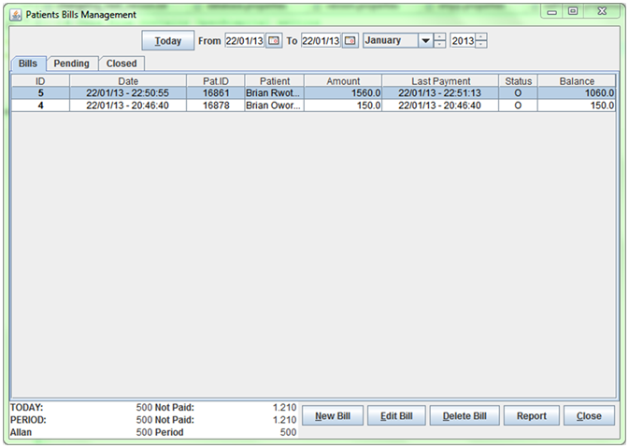

The application shows in the bottom panel the **Incomes Table** with the amounts **PAID** and **NOT PAID** within **TODAY** and within the visualized **PERIOD**

The **Incomes Table** shows the current user **PAID** and **NOT PAID** within **Today**

So the **Incomes Table** will show follow informations:

* **First Row**: the **PAID** and **UNPAID** within **Today**
* **Second Row**: the **PAID** and **UNPAID** within the visualized **Period**
* **Third Row**: the **PAID** and **UNPAID** for the current **user** within **Today**

While the admin user will be able to filter all incomes among all users that have been involved in some payments:

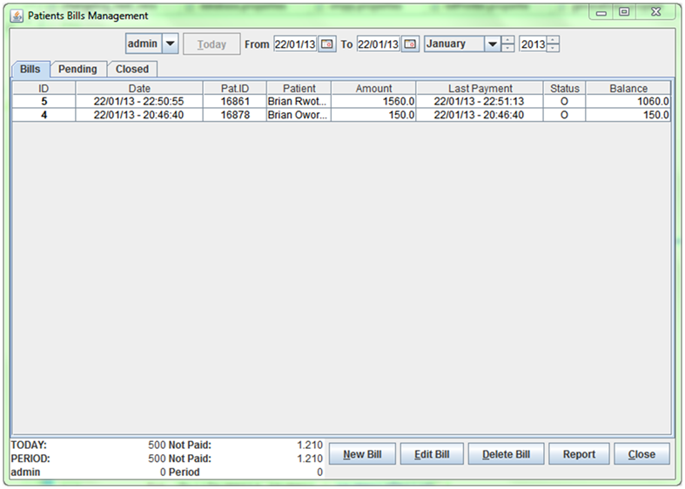

The application shows in the bottom panel the **Incomes Table** with the amounts **PAID** and **NOT PAID** within **TODAY** and within the visualized **PERIOD**

The **Incomes Table** shows the current user **PAID** and **NOT PAID** within **Today**

The **Admin** can filter the Incomes Table among other users involved in some payments

# Vaccines (Patient Vaccines)

## Main Characteristics

Vaccines functionality allows managing vaccines for all the patients registered. It is possible to register vaccinations, modify or delete them. A specific search function is also available.

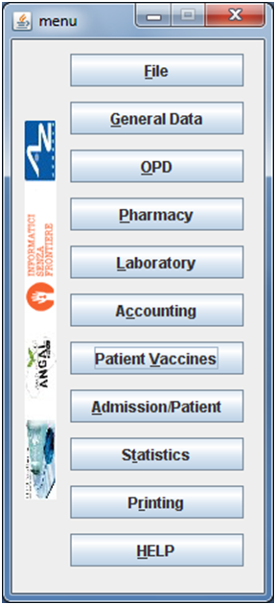

Click here or digit “CTRL+V” to enter in the ***Patient vaccines browsing*** screen

## Functions of Admission/Patients

All functions available under **Patient Vaccines** are accessible from thewindow ***Patient vaccines browsing*** window showed below.

By default the window shows in **Data table** all the vaccinations currently present in the system.

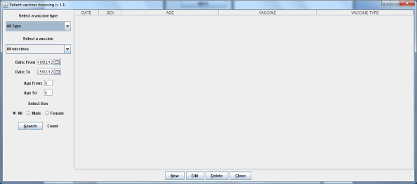

The following functions are accessible from the **Buttons Panel** ofthe window ***Patient vaccines browsing*** window**:**

* **New** to insert a new vaccination
* **Edit** to modify an already stored vaccination
* **Delete** to delete an already stored vaccination
* **Close** to exit from the function Patient Vaccines and return to the main menu’

Furthermore a search function is available using the **Selection panel** on the left of the window.

### Search vaccinations

Queries about vaccinations can be done using the search criteria available on the **Selection panel** area of the window (left side of the window). Results of your search are showed on the **Data table** area.

Doing the selection, data about vaccinations can be selected by choosing specific fields among the following ones:

* **Vaccine type:** by selecting a Vaccine Type you will filter the Vaccine list
* **Vaccine.** You can select one vaccine or the value “All vaccines”  
    
  ***NB****: VaccineTypes and Vaccines can be defined by the Administrator.* *Ask to your Administrator how to do it or see* [*General Data*](#_General_Data_(General) *in this document.*
* **Date. “**DATE From” and “DATE To” allow the selection of all the vaccinations over the requested period
* **Age. “**Age From” and “Age To” allow the selection of all the patients subject to vaccinations by age
* **Sex.** All / Male / Female

After the selection press **Search** button; the system will show on **Data table** results of the search applying the criteria requested.

The function shows in the field “Count:” the number of vaccinations that are showed in **Data Table** (in the example they are 3).

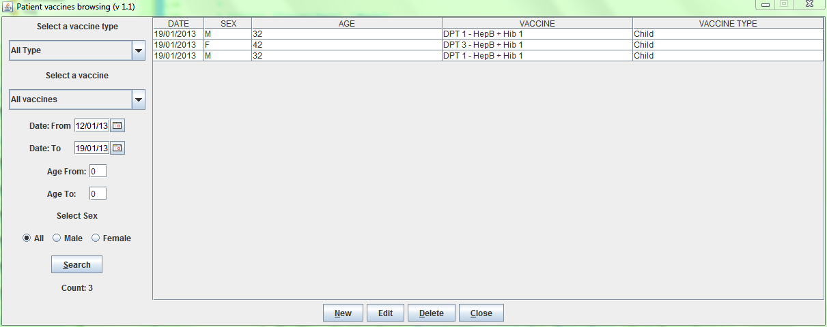

### Insert a new vaccination (New)

You can use this function to register a new Patient vaccination when executed.

Press **New** button in the ***Patient vaccines browsing*** windowto access the ***New patient vaccine*** window showed below.

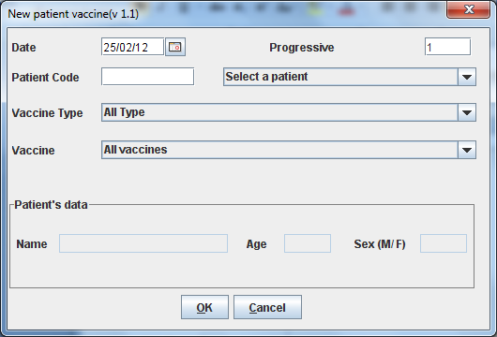

To record a new patient vaccination enters the following fields:

* **Date:** the date of the vaccination
* **Progressive:** the progressive number in the year (set automatically by the system)
* **Patient:** You can select the patient entering the **Patient code** or in alternative selecting a patient.
* **Vaccine type:** the Vaccine Type
* **Vaccine:** the Vaccine  
    
  ***NB****: VaccineTypes and Vaccines can be defined by the Administrator.* *Ask to your Administrator how to do it or see* [*General Data*](#_General_Data_(General) *in this document.*

When you finish entering data in the **Buttons Panel** you have the following choices:

* **Ok** to confirm data and record the Patient vaccination
* **Cancel** to close the window and to return to the ***Patient vaccines browsing*** window without record the patient vaccination

### Modify data of a recorded Patient vaccination (Edit)

First of all to modify data of a Patient vaccination you have to highlight it in the ***Patient vaccines browsing*** window. Once you’ve done this, press the **Edit** button. When the ***Edit Patient vaccine*** window showed below appears, the record is available for changes. Date, vaccine type and vaccine can be changed.

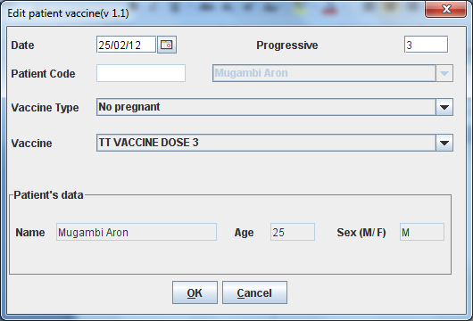

You may change all data except the patient associated with this vaccination.

When you finish entering data in the **Buttons Panel** you have the following choices:

* **Ok** to confirm new values (all the previous values will be lost)
* **Cancel** to close the window and to return to the Menu without applying any change

### Delete a Patient vaccination (Delete)

First of all to delete a stored Patient vaccination you have to highlight it in the ***Patient vaccines browsing*** window. Secondly press the **Delete** button. Theconfirmation window showed below will appear. The vaccination can then be deleted. Deleted vaccinations won’t be available anymore.

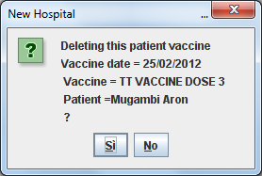

## Vaccines Extended (Patient Vaccines)

Since OpenHospital version 1.6 you can extend the Vaccine functionality by changing the *PATIENTVACCINEEXTENDED* flag in the configuration file. Ask to your Administrator how to do it or read the *Administrator’s Guide*.

### New Vaccine Browsing (v 1.1.)

The new window will appear like the following:

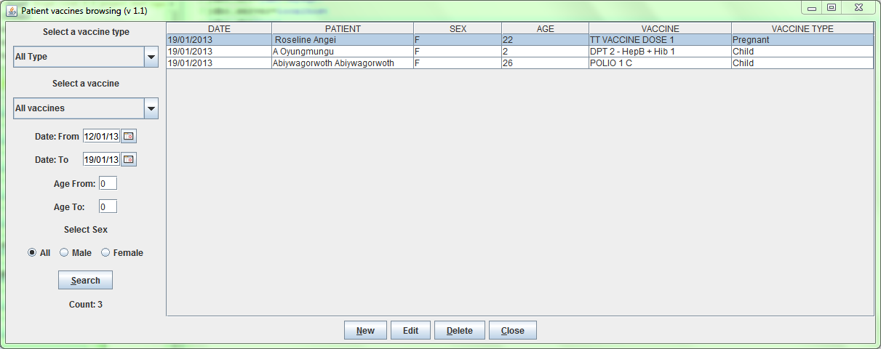

The only difference is the new column about the name of the patient for a fast research.

# Admission/Patient (Admission/Patient)

## Main Characteristics

Admission/Patient functionality allows registering a new patient, to modify his/her personal details, to browse his/her history, and to admit him/her in a hospital ward.



Click here or digit “ALT+A” to enter in the ***Patient browser*** screen

***NB****: you can also start an OPD registration from here if the OPDEXTENDED flag is set to YES. Ask to your Administrator how to do it or read the Administrator’s Guide.*

## Functions of Admission/Patients

All functions available under **Admission/Patient** are accessible from the ***Patients browser*** window showed below.

By default the window shows in **Data table** all the patients currently present in the system.

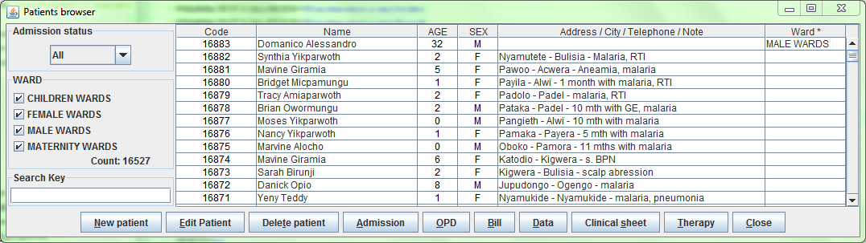

***NB****: If the patients list become huge it is possible to experience a slowdown of the system depending on the network settings. It is possible to optimize the use of memory by changing the flag ENHANCEDSEARCH in configuration file.* *Ask to your Administrator how to do it or read the Administrator’s Guide.*

The following data are shown in the ***Patients browser*** window:

* **Code**: the patient code (automatically generated by the application
* **Name**: the patient full name
* **Age**: the patient age in years
* **Sex**: the patient sex
* **Address / City / Telephone / Note**: all these informations separated by a “-“
* **Ward**: the ward where this patient is currently admitted; this field is blank if the patient is not admitted in the hospital in this moment

The following functions are accessible from the **Buttons Panel** ofthe window ***Patients browser*** window**:**

* **New Patient** to insert a new patient
* **Edit Patient** to modify an already stored patient
* **Delete Patient** to delete an already stored patient
* **Admission** to manage the admission of the patient in the hospital
* **OPD** to start an OPD visit on the selected patient
* **Bill** to start a Bill on the selected patient
* **Data** to modify data of a patient and to modify the history of his admissions/out of patient visits as well as his/her malnutrition data
* **Clinical sheet** to analyse the clinical sheet of a patient and print it
* **Therapy** to manage the therapy of a patient
* **Close** to exit from the function Admission/Patients and return to the main menu

***NB****: It is possible to have a* ***Merge*** *function that might help in case of double patient registration, by changing the flag MERGEFUNCTION in configuration file.* *Ask to your Administrator how to do it or read the Administrator’s Guide.*

Furthermore a search function is available using the **Selection panel** on the left of the window.

### Search patient

Queries about Patients can be done using the search criteria available on the **Selection panel** area of the window (left side of the window). Results of your search are showed on the **Data table** area.

Doing the selection, data about patients can be selected by choosing specific fields among the following ones:

* **Admission status.** Values admitted are:
* **ALL** (all patients are included in the selection)
* **Admitted** (only patients admitted are included in the selection)
* **Not admitted** (only patients not admitted are included in the selection)
* **Ward.** You can select one or more wards between Maternity, Nursery, Surgery, Internal medicine  
    
  ***NB****: Wards can be defined by the Administrator.* *Ask to your Administrator how to do it or see* [*General Data*](#_General_Data_(General) *in this document.*
* **Search criteria.** You can digit the complete name of a patient or only same characters: the system will show all the patients that have the entered characters (Examples are: if you enter “solo wa” all patients that have “solo wa” in the name will be selected, “Solomon Wakunga” but also “Kamwa Solonik” will be showed).

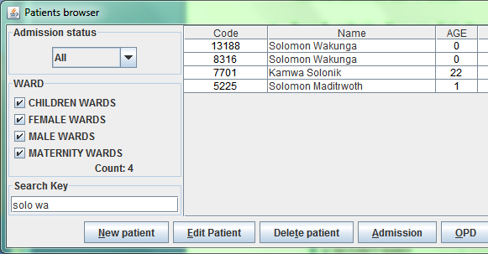

### Search patient Enhanced

OpenHospital, since version 1.6, allows optimizing memory usage when the number of registered patients becomes huge, by changing the *ENHANCEDSEARCH* flag in the configuration file. Ask to your Administrator how to do it or read the *Administrator’s Guide*.

Once the enhanced search has been enabled the new ***Patients browser*** window will looks like following one:

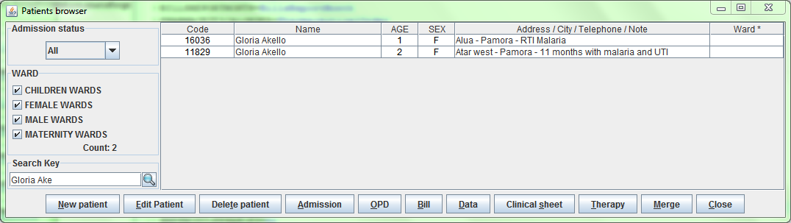

Initially the list looks empty. In order to show some patient you must enter a search criteria in **Search Key** field and the press the search () button and the window will show the only patients matching specified criteria.

***NB****: to show the full patient list again, is enough to press the search button with an empty criteria*

## Insert a new Patient (New Patient)

You can use this function to register a new Patient when she/he is admitted in the Hospital.

Press **New Patient** button in the ***Patients browser*** windowto access the ***New Patient*** window showed below.

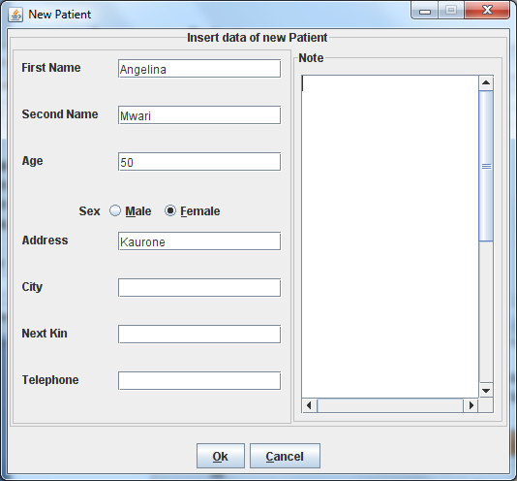

To record a new patient enter the following fields:

* **First name:** the first name
* **Second name:** the last name or other names
* **Age:** the age in year
* **Patient sex:** Male/female
* **Address:** the address where he/her comes from
* **City:** the city where he/her comes from
* **Next kin:** his/her most closest relative
* **Telephone**: his/her telephone number
* **Note:** It is a free text

When you finish entering data in the **Buttons Panel** you have the following choices:

* **Ok** to confirm data and record the Patient
* **Cancel** to close the window and to return to the ***Patient browser*** window without record the patient

### Modify data of a recorded Patient (Edit Patient)

First of all to modify data of a Patient you have to highlight it in the ***Patient browser*** window. Once you’ve done this, press the **Edit Patient** button. When the ***New Patient*** window showed below appears, the record is available for changes. All data can be changed.



When you finish entering data in the **Buttons Panel** you have the following choices:

* **Ok** to confirm new values (all the previous values will be lost)
* **Cancel** to close the window and to return to the Menu without applying any change

### Delete a Patient (Delete Patient)

First of all to delete a stored Patient you have to highlight it in the ***Patients browser*** window. Secondly press the **Delete Patient** button. The name of the Patient will be showed in the ***Delete Patient*** window below. The record can then be deleted. Deleted records won’t be available anymore. *The patient will not completely remove from the system and you can ask to the Administrator to rescue his/her data at any time.*

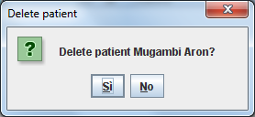

In the **Buttons Panel** you have the following choices:

* **Si** to confirm the record deletion
* **No** to close the window and return to the previous window

## Insert a new Patient Extended (New Patient)

Since OpenHospital version 1.3.1 you can extend the New Patient functionality by changing the *PATIENTEXTENDED* flag in the configuration file. Ask to your Administrator how to do it or read the *Administrator’s Guide*.

### New features

The **New Patient Extended** module affords the following improvements:

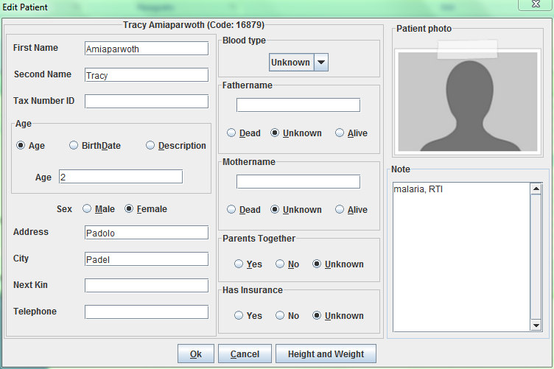

To record a new patient enter the following fields:

* **Tax Number ID**: is the national ID or other ID you may use to identify univocally the patient
* **Age / BirthDate / Description**: the age can be specified in three different ways:  
    
  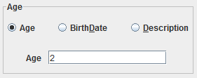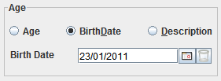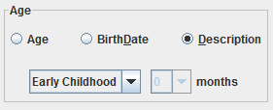  
    
  In any case it will be converted to an age in years in the ***Patients browser*** window.
* **BloodType**: it can be 0+, A+, B+, AB+, 0-, A-, B-
* **Father**: you can specify the father name and if is still alive
* **Mother**: you can specify the mother name and if is still alive
* **Parents Together**: you can specify if the parents are still together
* **Has Insurance**: you may specify if the patient has an health financial protection
* **Photo**: if the computer has a webcam it could be used to shoot a patient picture
* **Height and Weight functionality**: with this functionality you can register height and weight of the patient

***NB****: AgeTypes (Descriptions) can be defined by the Administrator.* *Ask to your Administrator how to do it or see* [*General Data*](#_General_Data_(General) *in this document.*

### Height and Weight functionality (Height and Weight)

You can use this function to register the height and the weight of the patient in a specific date when she/he is registered the first time and at any time you need.

Press **Height and Weight** button in the **New Patient Extended** windowto access the ***New Patient*** window showed below:

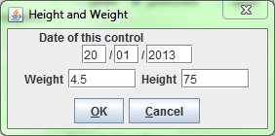

To record a new patient enter the following fields:

* **Date of this control**: the system automatically set the date of today
* **Weight**: the weight of the patient; you may use any kind of measure with decimal notation
* **Height**: the height of the patient; you may use any kind of measure with decimal notation

### Patient Photo (New Photo)

You can extend the New Patient functionality by changing the *VIDEOMODULEENABLED* flag in the configuration file. Ask to your Administrator how to do it or read the *Administrator’s Guide*.

Once the video module has been enabled the **New Patient Extended** window will looks as follow:

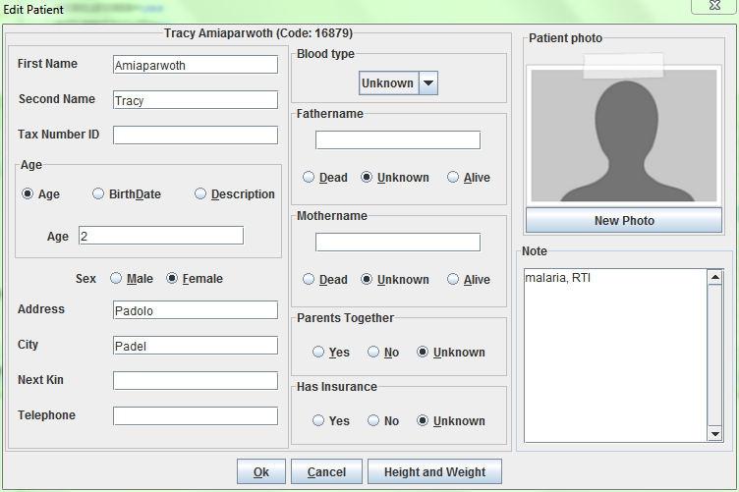

By clicking on **New Photo** button the webcam should be activated (check any light on the device) and in the template you should see the “eye-view” of the camera.

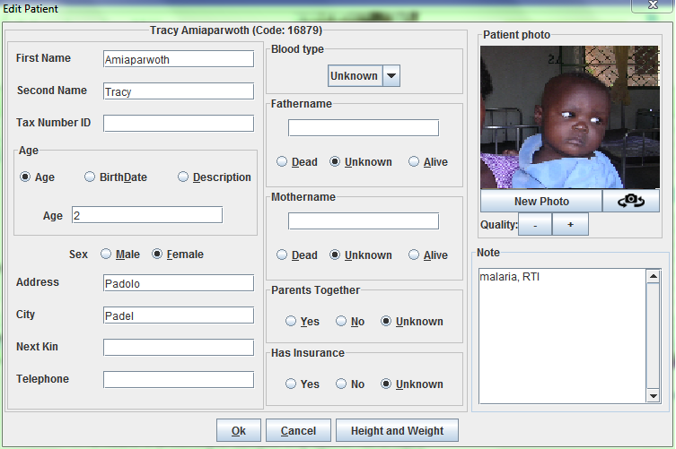

By clicking again on **New Photo** button you will make a shot ready to be saved in the system attached at the patient informations.

#### Camera settings (switchcam.png)

If nothing happens when you press on **New Photo** button you can press the **switch camera** button  that allows switching among the webcams connected to the computer if more than one; if only one camera is connected to the computer it is useful to reset the camera settings and restart it.

Once the camera is activated and you can see the “eye-view” of the camera, you may press on “+” or “-“ to increase or reduce the image quality.

OpenHospital will try automatically to set the best quality for any webcam connected to the computer and will remember the last settings used.

***NB****: If the camera refuse to work is possible to check the problem deeper changing the flag DEBUG in configuration file.* *Ask to your Administrator how to do it or read the Administrator’s Guide.*

## Admission functions (Admission)

The admission functions include the managing of a patient admission, including surgery, delivery, and discharge.

To access the Admission function, first of all you have to highlight the Patient in the ***Patients browser*** window. Secondly press the **Admission** button.

If the patient is not admitted then the ***New admission*** window appears.

If the patient is already admitted then the ***Edit admission record*** window appears.

### Start the admission of a patient (Admission)

Once a patient is registered, he/her can be admitted in a hospital ward.

First of all to insert the admission of a patient you have to highlight the patient in the ***Patients browser*** window. Once you’ve done this, press the **Admission** button. The ***New admission*** window showed below appears (if the patient is already admitted the ***Edit admission record*** window appears).

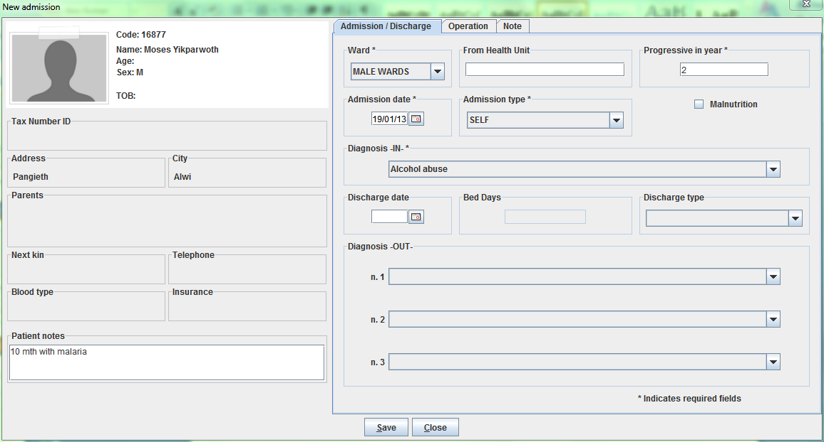

To start an admission you have to enter the following fields (on the right side of the window):

* **Ward:** the ward where the patient is admitted
* **From health Unit:** (not mandatory) in case of referral you may type the facility where the patient comes from
* **Progressive in year:** is the progressive number per year and per ward automatically set by the system, anyway you may change it if needed
* **Admission date:** the date of admission, automatically set as today
* **Admission type**: the type of admission (ie. Ambulance, Self, Referral, etc...)
* **Malnutrition** (not mandatory) in case of malnutrition you may check this box so you will manage the malnutrition control from the ***Patient data*** window (see Malnutrition control function).
* **Diagnosis IN:** it is the diagnosis the patient has been admitted with

***NB****: Wards, AdmissionType and Diagnosis can be defined by the Administrator.* *Ask to your Administrator how to do it or see* [*General Data*](#_General_Data_(General) *in this document.*

***NB****: The "Progressive in year" field is automatically populated by the program; in case of maternity the counter can starts from first January or from first June as far as the current normative ask to the health facilities; to change this behaviour please ask to your Administrator to set the MATERNITYRESTARTINJUNE* *flag in the configuration file or read the Administrator’s Guide.*

When you finish entering data in the **Buttons Panel** you have the following choices:

* **Save** to confirm the values on the window
* **Close** to close the window and to return to the ***Patient browser*** window without applying any changes

Once you press the Save button the ***New admission*** window will close and you will see the status changed in the ***Patients browser*** window as follow figure:

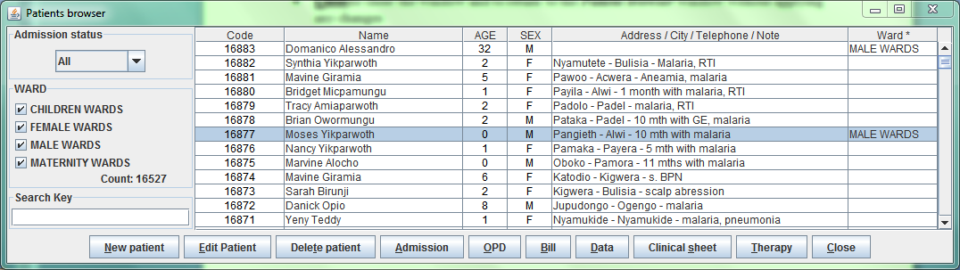

### Insert/modify Surgery data

First of all to insert/modify operations data of a patient admission you have to highlight the patient in the ***Patients browser*** window. Once you’ve done this, press the **Admission** button. The ***Edit admission record*** window showed above appears.

You can also insert/modify operations data directly when you are inserting or modifying an admission by selecting the **Operation tab** in the top of the window

Operations data that you can manage are:

* **Operation date:** the operation date
* **Operation type:** the operation type
* **Operation result:** the result of the operation
* **Transfusion Units:** (not mandatory): how many unit of blood have been used

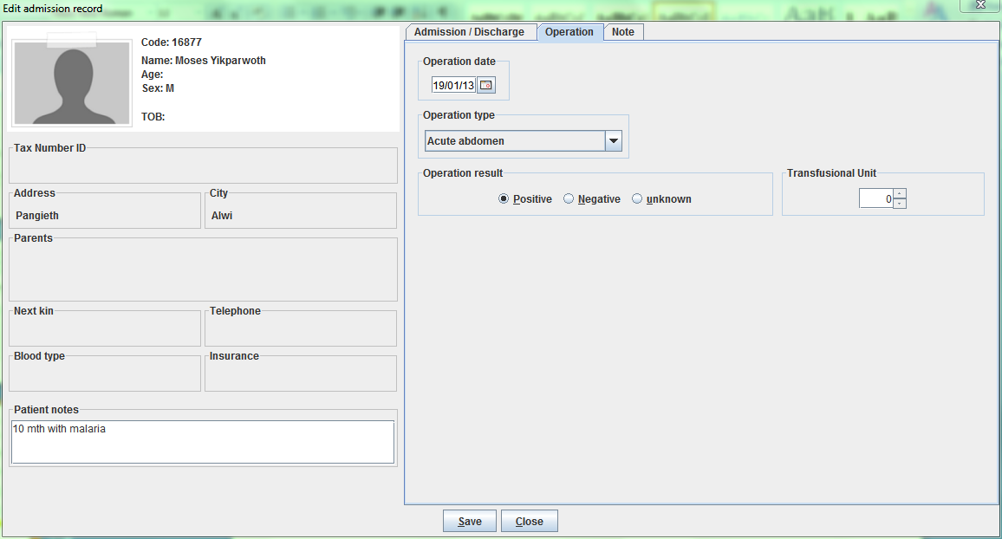

***NB****: OperationType and Operations can be defined by the Administrator.* *Ask to your Administrator how to do it or see* [*General Data*](#_General_Data_(General) *in this document.*

### Insert/modify Delivery data

If a female patient is admitted, the Maternity ward will be present in the ward list and, by selecting it, the ***Edit admission record*** window will change as showed below:

In the window extension you will be able to specify much information about the Maternity Case, like:

* **Visit**: date: the date of a visit before the delivery, if any
* **Weight**: the weight of the mother before the delivery, if measured
* **Treatment**: the treatment type given to the mother, if any
* **Delivery Date**: the date of delivery
* **Delivery Type**: the type of delivery
* **Delivery Result Type**: the result of the delivery
* **Control dates**: the dates of control after the delivery
* **Abort date**: the date of the abort if the result of the delivery was an abortion

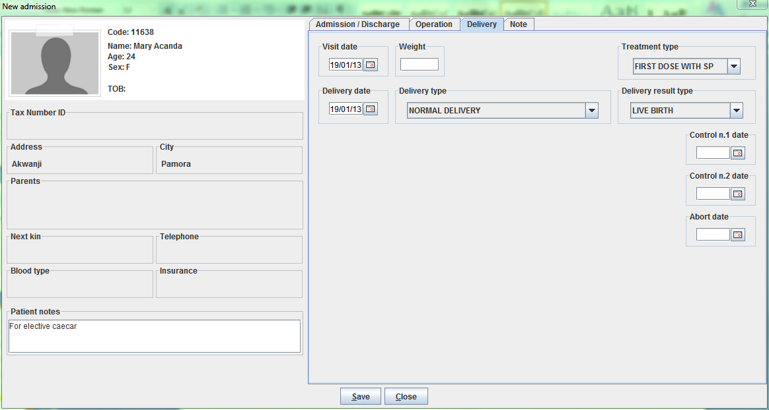

***NB****: TreatmentType, DeliveryType and DeliveryResultType can be defined by the Administrator.* *Ask to your Administrator how to do it or see* [*General Data*](#_General_Data_(General) *in this document.*

### Discharge of a patient (Admission)

First of all to discharge a patient from the hospital you have to highlight the patient in the ***Patients browser*** window. Once you’ve done this, press the **Admission** button. The ***Edit admission record*** window showed above appears.

You have to enter the following data:

* **Discharge date:** the date of discharge
* **Discharge type:** the type of discharge
* **Diagnosis OUT:** it is the diagnosis the patient has been discharged with

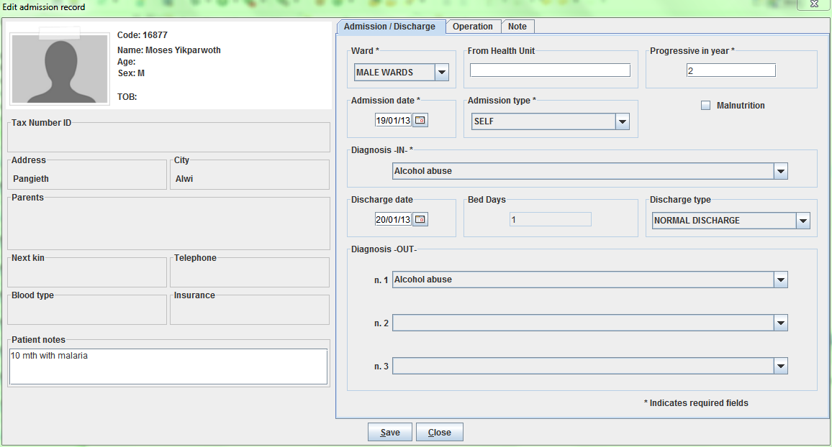

***NB****: DischargeTypes and Diseases can be defined by the Administrator.* *Ask to your Administrator how to do it or see* [*General Data*](#_General_Data_(General) *in this document.*

When you finish entering data in the **Buttons Panel** you have the following choices:

* **Save** to confirm the values on the window
* **Close** to close the window and to return to the ***Patient browser*** window without applying any changes

Once you press the Save button the ***Edit admission record*** window will close and you will see the status changed in the ***Patients browser*** window as follow figure:

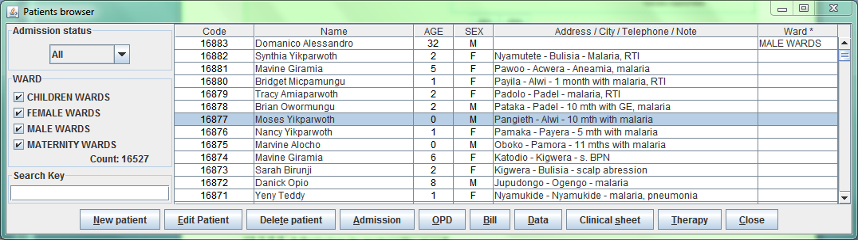

## OPD (OPD)

If *OPDEXTENDED* flag is set as YES in the configuration file (ask to your Administrator) the button **OPD** in the Admission/Patient window will allow you to start an OPD by selecting the related patient first (see Create a new patient visit (New) for more informations)

## Bill (Bill)

The button **Bill** in the Admission/Patient window will allow you to start a bill by selecting the related patient first (see #Insert a new bill (New Bill) for more informations)

## Manage Patient historical data (DATA)

This function allows modifying data of a Patient and modify/delete the history of out of patients/admissions of a patient. Malnutrition can also be managed with this function.

To access the Patient historical data function, first of all you have to highlight the Patient in the ***Patient browser*** window. Secondly press the **DATA** button. The ***Patient data*** window showed below will appear.

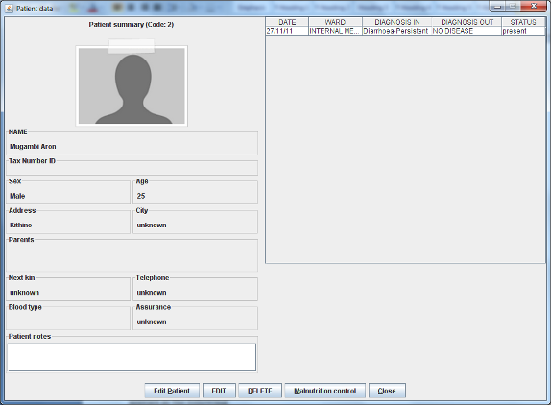

The screen is divided in three areas:

* **Patient summary** (on the left)
* **Data table** (on the right)
* **Buttons panel**

The **Patient summary** area shows you a summary of patient data.

**Data table** shows you a summary of all the out-patients (OPD) visits and all the admissions related to the patient.

The following functions are accessible from the **Buttons Panel** ofthe window ***Patient data:***

* **Edit Patient** to modify an already stored patient (it is the same **Edit** function of the ***Patient browser*** window)
* **EDIT** to modify data of an admission oran out-patient visit
* **DELETE** to delete an already stored admission
* **Malnutrition control** to create, modify or delete malnutrition control data of a patient
* **Close** to exit from the function ***Patient*** ***Data*** and return tothe ***Patients browser*** window

### Modify data of an admission or out-patient visit (EDIT)

First of all to modify data of an admission or out-patient visit you have to highlight it in **Data table** of the ***Patient Data*** window. Once you’ve done this, press the **EDIT** button. When the ***Edit admission record*** window showed below appears, the record is available for changes. All data can be changed.

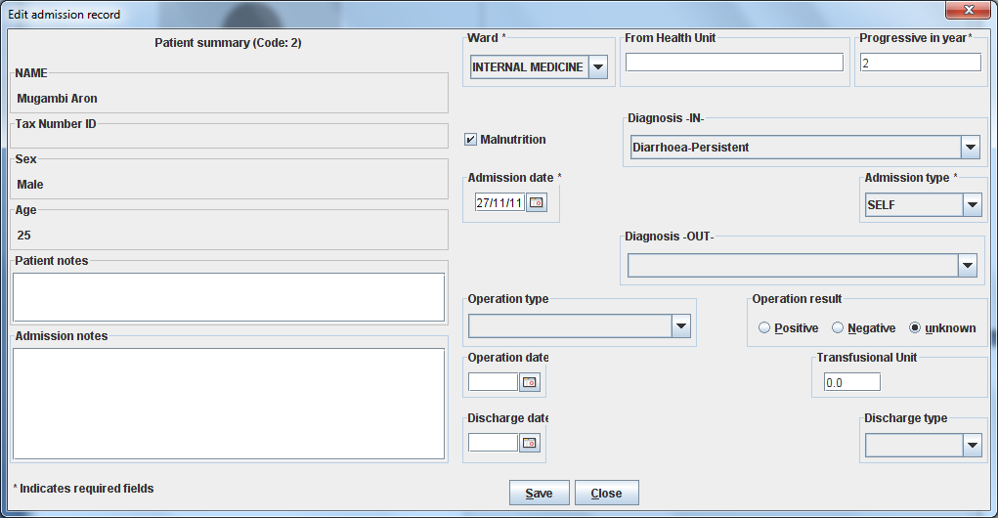

When you finish entering data in the **Buttons Panel** you have the following choices:

* **Save** to confirm new values (all the previous values will be lost)
* **Close** to close the window and to return to the Menu without applying any changes

### Delete an admission (DELETE)

First of all to delete a stored admission you have to highlight it in the ***Patient Data*** window. Secondly press the **DELETE** button. A confirmation window will appear and it is showed below. Now the admission can be deleted. Deleted admissions won’t be available anymore.

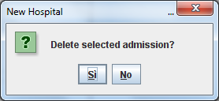

In the **Buttons Panel** you have the following choices:

* **Si** to confirm the record deletion
* **No** to close the window and return to the previous screen

### Manage malnutrition control of a patient (Malnutrition control)

Malnutrition control function is available for all and only the admissions that have concerns about malnutrition (malnutrition field activated in ***New admission*** window, see next page).

Malnutrition Control function allows you to register specified visits for those patients who need to control his/her Weight/Height index.

To access the Malnutrition control function, first of all you have to highlight the admission in the ***Patient data*** window. Secondly press the **Malnutrition control** button. The ***Malnutrition browser*** window showed below will appear.

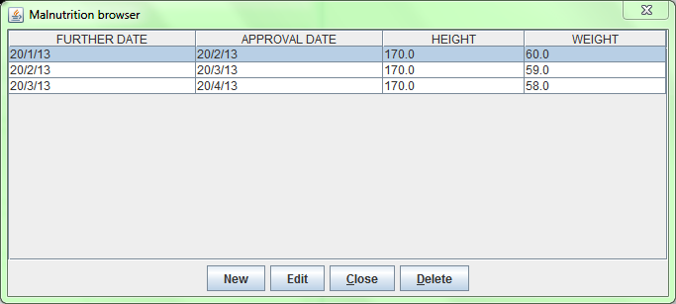

From this function you can insert (**New**) a new malnutrition control, modify (**Edit**) or **Delete** an existing malnutrition control already stored.

#### Insert a new control (New)

By pressing the **New** button from the ***Malnutrition Browser*** window you will access to the ***Malnutrition*** window below:

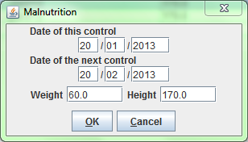

To record a new control enter the following fields:

* **Date of this control**: the system automatically set the date of today
* **Date of next control**: the date of the next planned control
* **Weight**: the weight of the patient; you may use any kind of measure with decimal notation
* **Height**: the height of the patient; you may use any kind of measure with decimal notation

## Clinical Sheet (Clinical sheet)

The Clinical Sheet functionality is very similar to the **DATA** functionality (see ***Patients browser*** window)

To access the Clinical sheet function, first of all you have to highlight the Patient in the ***Patients browser*** window. Secondly press the **Clinical sheet** button. The ***Patient data*** window showed below will appear.

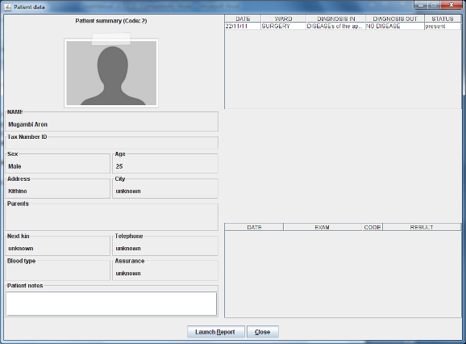

The windows doesn't allow you to change data but, for the selected patient, it shows you all the out-patient (OPD) visits, the Admissions and his/her Laboratory exams; by clicking on a row in the **Data table** on the top of the window, the related laboratory exams will be showed as follow:

* selected row is an Admission: all the exams done between the admission date and the discharge date will be showed in **Data table** on the bottom
* selected row is an out-patient (OPD) visit: all the exams done after the selected OPD visit until next one (if any) or next admission date (if any) will be showed in the **Data table** on the bottom

In the **Buttons Panel** you have the following choices:

* **Launch report** to print the clinical sheet of a patient
* **Close** to close the window and to return to the ***Patient browser*** window without applying any changes

## Therapy management (Therapy)

First of all to manage the therapy of a patient you have to highlight the patient in the ***Patients browser*** window. Once you’ve done this, press the **Therapy** button. The specific window for therapy management of the selected patient will appear. The window has no name, we call it ***Therapy*** window.

From the ***Therapy*** window you can insert, modify or remove a therapy.

From the ***Therapy*** window you can insert or remove a scheduled visit.

The window is complex, see the comments below to understand the structure.

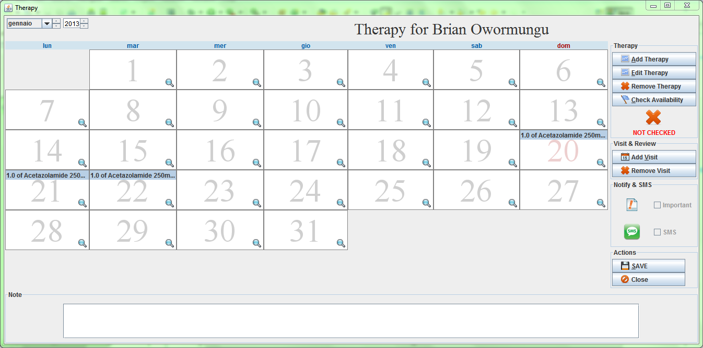

Shows the therapy of the day 21st

The window shows the month here selected

***Therapy*** window is the name of the window

Buttons panel on the right

### Add a therapy (Add Therapy)

To add a new therapy for the patient press the **Add Therapy** button on the right of the window. The ***Therapy entry form*** window showed below will appear.

A therapy defines for every pharmaceutical the quantity, frequency and period of use.

You can add more than one therapy for the same patient. The set of therapies defined for a patient is called “Therapy plan”.

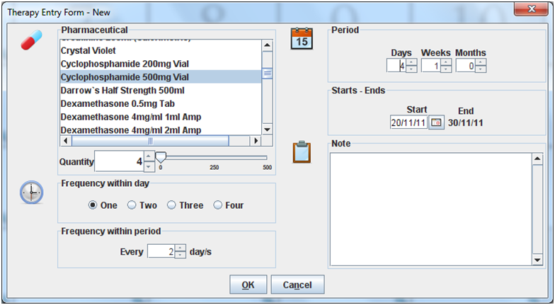

Cursor for large quantity definition

Small up/down arrows for small quantity definition

***NB***: To better explain how the function **Add a therapy** works, the ***Therapy*** window below (next page) shows the results of the therapy defined in the ***Therapy entry form*** window above.

To add a therapy you have to enter the following fields:

* **Pharmaceutical of the therapy**: in the example above *Cyclophosphamide 500mg* (highlight the desired pharmaceutical)
* **Quantity**: set the quantity; you can define it by clicking on the small up/down arrows (for small quantity) or moving the cursor on the right (for large quantity); in the example above the selected value is “4”
* **Frequency within the day**: set how many times (frequency) the dose has to be given within one day (possible choices are: one, two, three, four); in the example above “One” means once per day
* **Frequency within period**: set the periodicity of the therapy; in the example above every two days (a quantity of 4 *Cyclophosphamide 500mg* every two day has to be given)
* **Period**: set how long is the therapy, to do it select days, weeks and months; in the example above the therapy is 11 days long (4 days and 1 week)
* **Starts – Ends**: set start and end date of the therapy; in the example the therapy starts on November 20th and finish on November 30th
* **Note** (not mandatory): free text available for notes

When you finish entering data in the **Buttons Panel** you have the following choices:

* **Ok** to confirm data of the therapy. The therapy is not saved until you do not confirm it with the **SAVE** button in the ***Therapy*** window (see **Save function** described below)
* **Cancel** to close the window and to return to the ***Therapy*** window

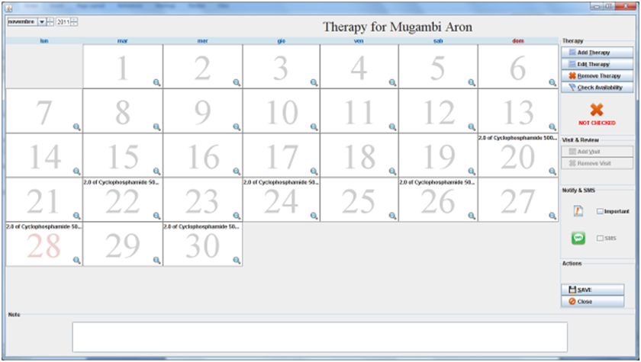

Highlight it if you want to modify the therapy **Edit Therapy**

Check the availability of pharmaceuticals

### Modify a therapy (Edit Therapy)

First of all to modify a therapy you have to highlight one occurrence of the therapy (see box above) in the ***Therapy*** window. Once you’ve done this, press the **Edit Therapy** button. The ***Therapy entry form*** window will appear. You can modify all data as in the **Add a therapy** function.

See Add a therapy (Add Therapy) function for detailed description.

### Remove a therapy (Remove Therapy)

First of all to remove a therapy you have to highlight one occurrence of the therapy (see box above) in the Therapywindow. Pay attention! Once you’ve done this, pressing the **Remove Therapy** button, the therapy is removed. Therapy can be removed before or after the final saving (see [**Save function**](#_Save_function_(SAVE))described below)

### Check availability of the pharmaceuticals (Check availability)

When you have entered the therapy plan (all the therapies of a patient) you can check the availability of the related pharmaceuticals in the hospital. If the pharmaceutical/s checked is/are present in the quantity requested by the therapy plan on the button panel on the right side of the ***Therapy*** window you see in green colour the text ”OK”

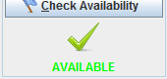

otherwise the application shows the small window showed below, called ***Therapy not available:***

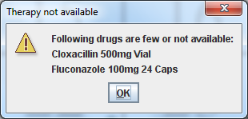

This window provides you only information that the therapy is not available and does not block the input of the Therapy plan. You have to click **OK** on the button to exit from the window.

After the check, on the **button panel** of the ***Therapy*** window you see in red colour the text “NOT AVAILABLE” if at least one of the involved drugs starting from today are not available or the test “AVAILABLE” otherwise.

Note: check can also be done therapy by therapy and not only at the end of the input of all the therapies.

Check function is not mandatory, you can save the therapy plan also without checking the presence of the pharmaceuticals in the hospital (see [**Save Function**](#_Save_function_(SAVE)) below).

### Save function (SAVE)

When you have completed the input of the therapy plan press the **SAVE** button on the button panel of the ***Therapy*** window. Be aware that the therapy plan is saved when on the screen appears the ***Messaggio*** window showed below with the message “Therapies plan saved”.

If you have not done the availability check (see **Check availability function**) the ***Not checked*** window showed below appears.

On the **Buttons Panel** you have the following choices:

* **Ok** to confirm the therapy plan; you have to be aware that if you press **Ok** you have not checked the existence of the pharmaceuticals in the hospital. The application save the therapy plan and shows the confirmationwindowshowed below.
* **Annulla** to return to the ***Therapy*** windowwithout saving the therapy plan.

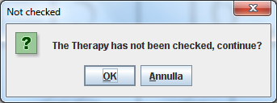

If you have done the availability check (see **Check availability function**) but the pharmaceuticals requested by the therapy plan do not exists in the hospital the ***Not available*** window showed below appears.

On the **Buttons Panel** you have the following choices:

* **Ok** to confirm the therapy plan; you have to be aware that if you press **Ok** you have saved a therapy but there are not the requested pharmaceuticals in the hospital. The application save the therapy plan and shows the confirmationwindowshowed below.
* **Annulla** to return to the ***Therapy*** windowwithout saving the therapy plan.

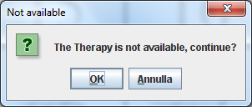

Either you have done the availability check that the pharmaceuticals are present in the hospital or you have not done the check, when the application shows the notification window belowthe therapies plan is saved.

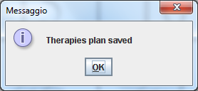

Press **OK** to finish.

### Close function (Close)

Close function allows you to exit from the ***Therapy window.*** Press the **Close** button to access the Close function. The ***Selezionare una opzione*** window showed below appears. On the **Button panels** you have the following choices:

* **Si:** this function is the same as the **Save function (SAVE)** described above
* **No** to return to the ***Therapy window*** without saving the therapy plan
* **Annulla:** to stop the function and return to the ***Therapy window*** without apply any change

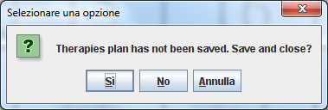

### Notify & SMS (not yet implemented)

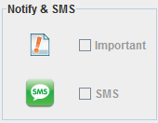

With these two checkboxes you can set the therapies plan for this patient as important and notifiable via SMS (not yet implemented)

## Merge function (Merge)

You can use this function to merge two patients’ histories in case of wrong double registration when she/he is admitted in the Hospital.

First of all to merge data of two patients you have to highlight them in the ***Patient browser*** window.

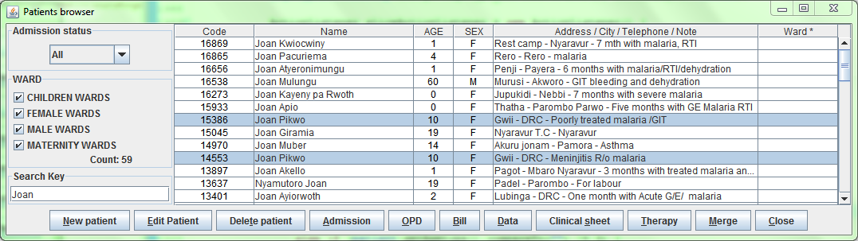

Once you’ve done this, press the **Merge** button. The ***Merge*** window showed below appears:

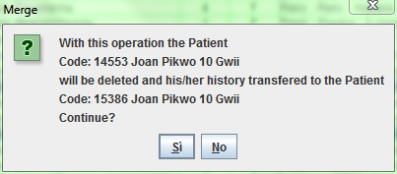

By pressing Si the patient with smaller Code will be deleted and all his/her history transferred to the other one, it’s to say:

* Admission History
* Height & Weight History
* Laboratory History
* OPD History
* Bills History
* Pharmaceuticals Stock Ward History
* Therapy History
* Visit History
* Vaccine History

The old patient will be then deleted.

### Different Names

In case you try to merge two patients with different names you will be asked to choose the final one, with the window showed below:

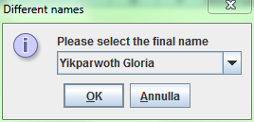

### Different Sex

In case you try to merge two patients with different sex you will be notice that the operation is not allowed, with the window showed below:

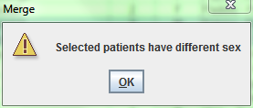

# Statistics (Statistics)

## Main Characteristics

This functionality is the most important in order to extract data registered in previous ones.

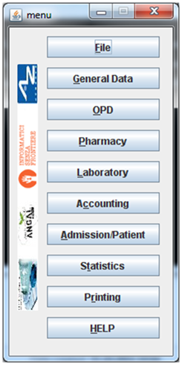

Click here or digit “ALT+T” to enter in the ***Patient browser*** screen

OpenHospital comes with a set of reports made for the Ugandan Ministry of Health (HMIS) and for Kenyan Ministry of Health (MOH) as well as national independent reports (OH). Anyway all these reports can be useful for any organization.

OpenHospital 1.7.0 comes with this set of reports:

* OH001 - Registered Patients
* OH003 - Registered patients by Age and Sex
* OH002 - Patients registered by origin
* OH004 - All incomes by price codes
* OH005 - Count outpatient
* OH006 - Count outpatient diagnosis
* OH007 - Lab monthly basic
* OH008 - Lab summary for OPD
* HMIS 108 - page 1 - 1. census info
* HMIS 108 - page 1 - 2. referrals
* HMIS 108 - page 1 - 3. operations
* HMIS 108 - In Patient (diagnosis In)
* HMIS 108 - In Patient (diagnosis Out)
* HMIS 105 - Opd attendance
* HMIS 105 - Opd referrals
* HMIS 105 - Opd by diagnosis
* HMIS 55b - Lab monthly formatted
* HMIS 33b - Weekly epidem. surveil.
* HMIS 33b - Weekly epidem. surveil. over 5 y.o.
* HMIS 33b - Weekly epidem. surveil. under 5 y.o.
* MOH 717 - Monthly Workload Report for Hospitals (Page1)
* MOH 717 - Monthly Workload Report for Hospitals (Page2)
* MOH 705A - Over 5 - Daily Outpatient Morbidity Summary Sheet
* MOH 705A - Under 5 - Daily Outpatient Morbidity Summary Sheet

## Report Launcher (Launch Report)

With this function you can produce all reports listed in previous paragraph. Once you press the **Statistics** button on the main menu the ***Report Launcher*** window showed below will appear:

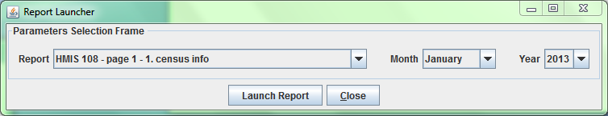

To produce one report you must operate as follow:

* Select a report from the list
* Specify the period (it could be month-year or from date-to date depending on the report)
* Press the **Launch Report** button

After some instants the JasperViewer® will show the generated report as follow:

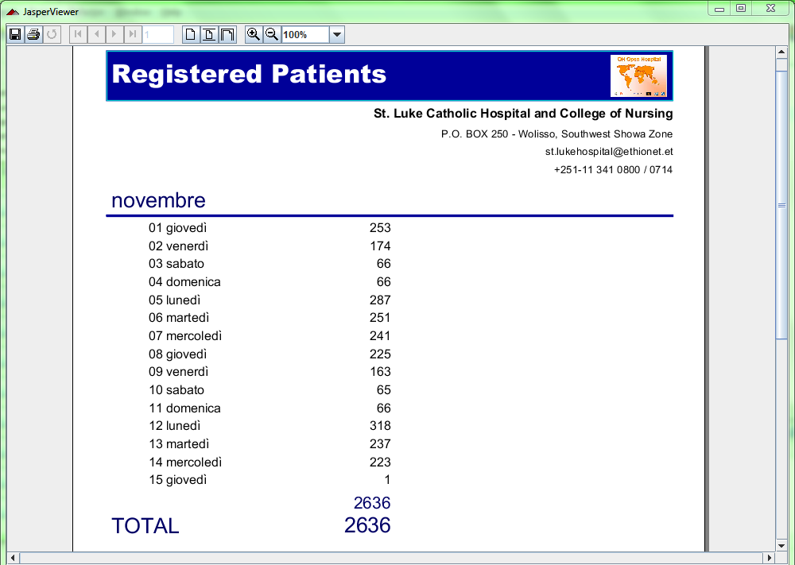

***NB****: By default an internal PDF viewer is used. You can use an external PDF reader by modifying the INTERNALVIEWER flag in the configuration file.* *Ask to your Administrator how to do it or read the Administrator’s Guide.*

You can save the report as PDF by clicking on save button () or printing it by clicking on print button ().

***NB****: A PDF copy of every report is always saved within the folders of OpenHospital.* *Ask to your Administrator how to do it or read the Administrator’s Guide.*

# Printing (Printing)

## Main Characteristics

This functionality is meant for print some information about the hospital like letterhead, list of exams, diseases, etc...



Click here or digit “ALT+R” to enter in the ***Patient browser*** screen

OpenHospital 1.7.0 comes at moment only with this couple of printings:

* Exams List
* Diseases List

## Printing

By pressing **Printing** from the main menu you access the ***Printing*** menu. From this menu you have the following printings available: **Exams List** and **Disease List.**

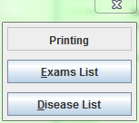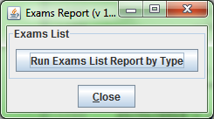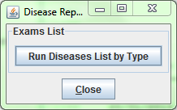

### Exams List (Exams List)

This report will produce a report about the list of exams, divided by types, as defined in the application by the Administrator.

### Disease List (Disease List)

This report will produce a report about the list of diseases, divided by types, as defined in the application by the Administrator.

# Communication (Communication)

## Main Characteristics

Since OpenHospital version 1.7 you can use the Communication module by changing the *XMPPMODULEENABLED* flag in the configuration file. Ask to your Administrator how to do it or read the *Administrator’s Guide*.

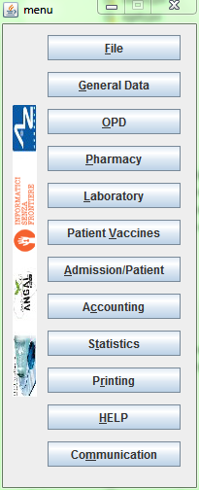

Click here or digit “ALT+M” to enter in the ***Patient browser*** screen

With this functionality you can chat and share informations with other users logged in the system, if in turn the application has been set in multi-user mode and an XMPP Server is active and running (Ask to your Administrator how to do it or read the *Administrator’s Guide).*

The functionality, up to OpenHospital 1.7.0, allows following tasks:

* Chat
* Admissions notifications
* Pharmaceutical Stock critical levels notifications
* Report sharing

## Chat

By pressing the **Communication** the ***Communication*** window showed below will appear:

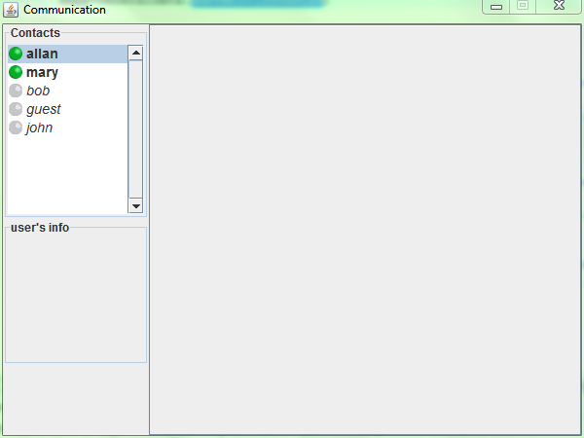

It shows all users logged in the system. Some of them have a green circle near their names: it means that they are currently logged in the system and they are the only ones we can interact with. Others have the name close to a grey circle: it means that they logged at least one time in the past but are not using the system in this moment.

By double-clicking on an active user (ie. Allan in the figure above) we may start a chat session with him/her, as showed in the figures below:

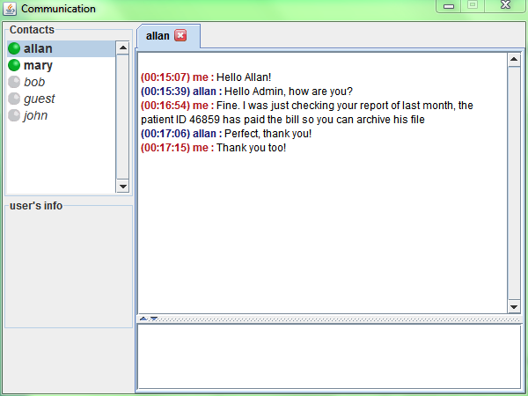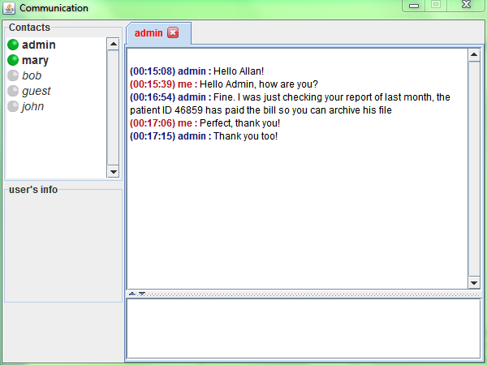

White box where to type our message

To send a message to Allan we must type it on the white box at the bottom then press “ENTER”; the message will be immediately forwarded to Allan; when Allan will do the same, his message will be immediately forwarded to us. Other users logged in (ie. Mary in the figures above) cannot see our conversation.

## Admission/Discharge Notifications

As told before, with the communication module we can share some events with other users.

In the ***New Admission*** window we will see a new box in the **Buttons Panel**, as showed below:

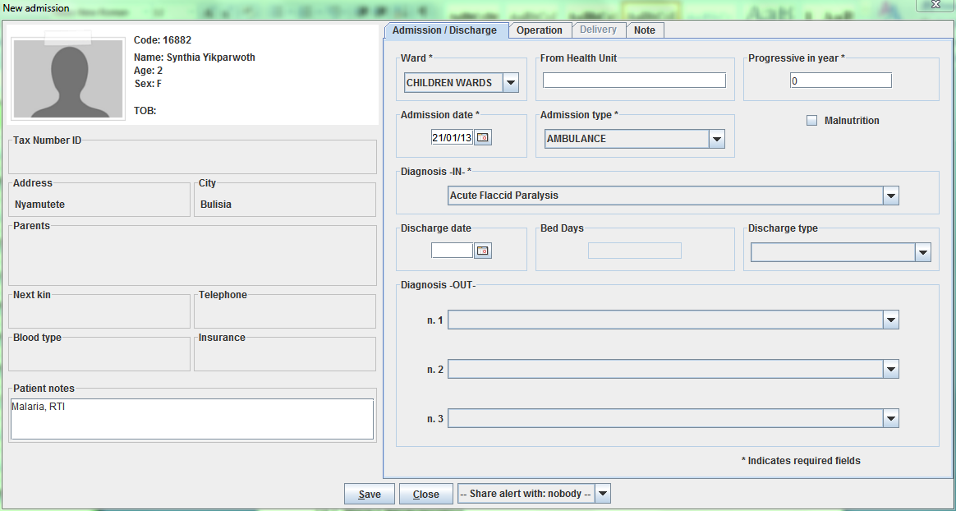

The box will list all users logged in the system in this moment (those ones with the green circle near the name) and you can decide to send an alert or not (nobody) in the moment we press the **Save** button.

### Admission Notifications

If we choose to send a notification about this new admission to user Allan, when we press the **Save** button he will see in his ***Communication*** window a message like “new patient admission:” followed by his/her name and the related ward.

An example of Allan ***Communication*** window is shown below.

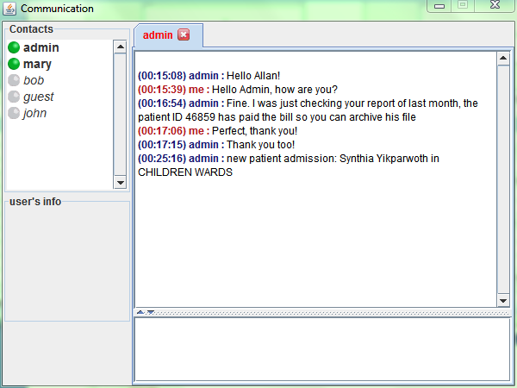

### Discharge Notifications

Similarly this would happen for discharge events. If we choose to send a notification about a discharge to user Allan, when we press the **Save** button he will see in his ***Communication*** window a message like “discharged patient:” followed by his/her name and the related DischargeType.

An example of Allan ***Communication*** window is shown below.

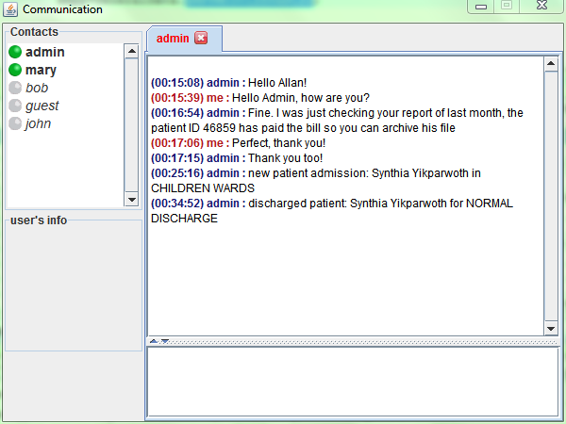

## Pharmaceuticals Critical Level Notifications

As told before, with the communication module we can share some events with other users.

In the ***Stock Movement Inserting - Discharge*** window we will see a new box at the bottom, as showed below:

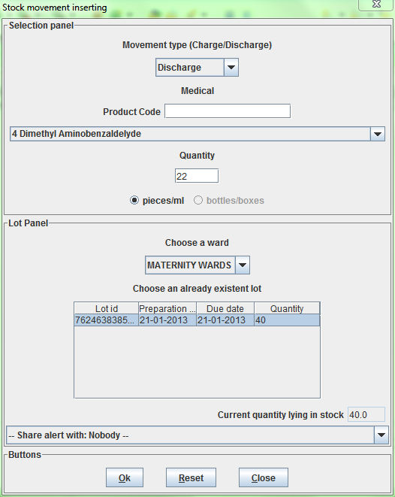

The box become active and useful only if the movement is going to reduce the selected pharmaceutical under the critical level. So we can decide to share this event with another user logged in the system at the moment we press the **Ok** button.

If we choose to send a notification about this discharging movement to user Allan, when we press the **Ok** button he will see in his ***Communication*** window a message like “ALERT:” followed by the pharmaceutical name and the text “is about to end” as showed below:

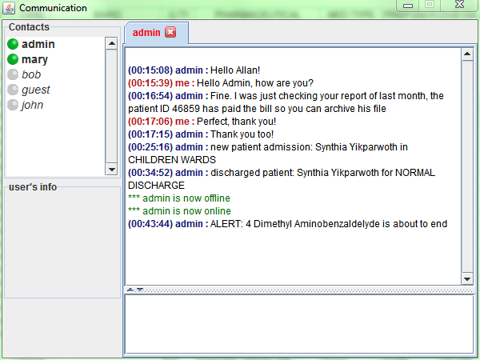

## Report sharing

As told before, with the communication module we can share some events with other users.

In the ***Report Launcher*** window we will see a new box at the bottom, as showed below:

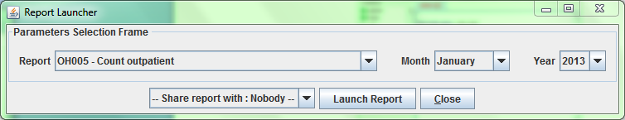

We can decide to produce and share the selected report with another user logged in the system at the moment we press the **Launch Report** button.

If we choose to share the report with user Allan, when we press the **Launch Report** button he will see in his ***Communication*** window a message like “*** admin wants to share with you this report:” followed by the report name and a clickable icon that will link Allan to the related report. An example of this message is shown below:

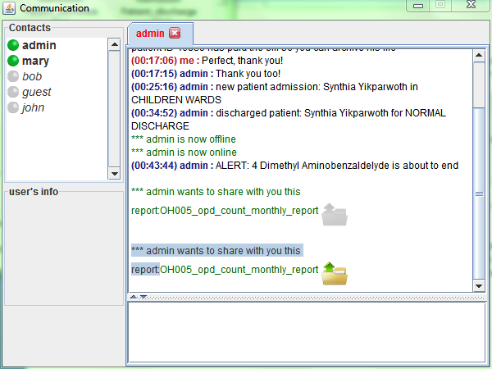

# General Data (General Data)

## Main Characteristics

One of the Administration task is the setup of OpenHospital through the **General Data** functionality. It allows defining all “types” and “data” that are going to be used in OpenHospital.

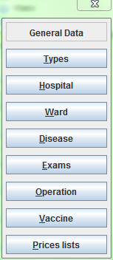

Click here or digit “ALT+G” to enter in the ***Patient browser*** screen

Once you’ve pressed on **General Data** buttonfrom the main menu you access the ***General Data*** menu. From this menu you have the following functions available:

* **Types**: will bring to Types menu
* **Hospital**: to set some Hospital informations (name, address, telephone, email, ecc...)
* **Ward**: to define which departments are in the hospital
* **Disease**: to define which diseases are diagnosed in the hospital
* **Exams**: to define which laboratory exams are performed in the hospital
* **Operation**: to define which surgical operations are provided by the hospital
* **Vaccine**: to define which vaccines are given in the hospital
* **Prices lists**: to define unitary costs of the services provided by the hospital

## Types (Types)

Once you’ve pressed on **Types** buttonfrom the ***General Data*** menu you access the ***Types*** menu:

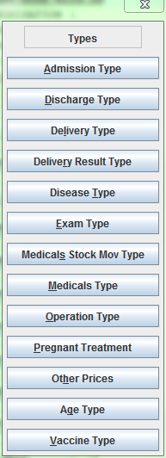

Click here or digit “ALT+T” to enter in the ***Patient browser*** screen

From the ***Types*** menu you have the following functions available:

* **Admission Type**: the way the patient is admitted in the hospital  
  *ie. Ambulance, Self, Referral, etc...*
* **Discharge Type**: the way the patient is discharged from the hospital  
  *ie. Healed, Unchanged, Dead, etc...*
* **Delivery Type**: the ways the mothers are assisted in childbirth  
  *ie. Normal Delivery, Caesarean Session, etc...*
* **Delivery Result Type**: the result you are interested to track in reporting  
  *ie. Live Birth, Newborn Death, Fresh Still Birth, etc...*
* **Disease Type**: the way you need to group similar diseases  
  *ie. Epidemic, Maternal, etc...*
* **Exam Type**: the way you need to group similar laboratory exams  
  *ie. Haematology, Parasitology, Serology, etc...*
* **Medicals Stock Mov Type**: the kind of movements, meant as charge or discharge, you may perform in the Medical Store  
  *ie. Charge, Discharge, Donation, Correction, etc...*
* **Medicals Type**: the way you need to group similar pharmaceuticals  
  *ie. Drugs, Chemical, Laboratory, etc...*
* **Operation Type**: the way you need to group similar surgical operations  
  *ie. Abdominal, Obstetrical, Orthopaedic, etc...*
* **Pregnant Treatment**: the treatments the hospital can provide to mothers  
  *ie. First dose with SP, Second dose with SP, etc...*
* **Other Prices**: extra services the hospital can provide (it will be reflected in Prices lists)  
  *ie. Admission Fee, Food, POP, etc...*
* **Age Type**: the age classifications you use in the hospital  
  *ie. Newborn, Childhood, Adult, Elderly, etc...*
* **Vaccine Type**: the way you need to group similar vaccines  
  *ie. Child, Adult, Pregnant, etc...*

### Admission Types (Admission Type)

Once you’ve pressed on **Admission Type** buttonfrom the ***Types*** menu you access the ***Disease Type Browsing*** window as showed below:

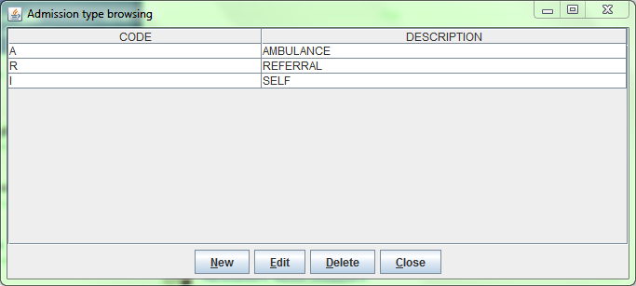

The functions available from this window (but similarly to other windows in ***Types*** menu) are:

* **New**: to enter a new type (cannot be used an already used code)
* **Edit**: to edit an already existing type (the code must be unchanged)
* **Delete**: to delete an already existing type (cannot be deleted if still used somewhere in the application)
* **Close**: to close the window

The Admission Types defined in this functionality will be reflected in the Admission function (see Start the admission of a patient and Discharge of a patient in this document).

### Discharge Types (Discharge Type)

Once you’ve pressed on **Discharge Type** buttonfrom the ***Types*** menu you access the ***Discharge Type Browsing*** window as showed below:

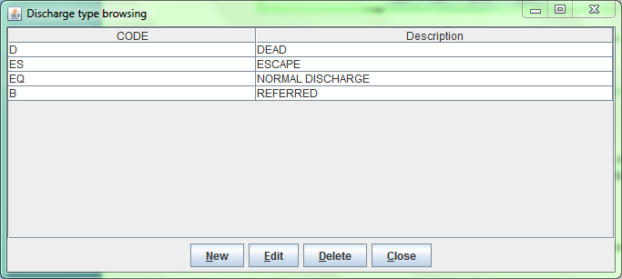

The functions available from this window (but similarly to other windows in ***Types*** menu) are:

* **New**: to enter a new type (cannot be used an already used code)
* **Edit**: to edit an already existing type (the code must be unchanged)
* **Delete**: to delete an already existing type (cannot be deleted if still used somewhere in the application)
* **Close**: to close the window

The Discharge Types defined in this functionality will be reflected in the Admission function (see Start the admission of a patient and Discharge of a patient in this document).

### Delivery Types (Delivery Type)

Once you’ve pressed on **Delivery Type** buttonfrom the ***Types*** menu you access the ***Delivery Type Browsing*** window as showed below:

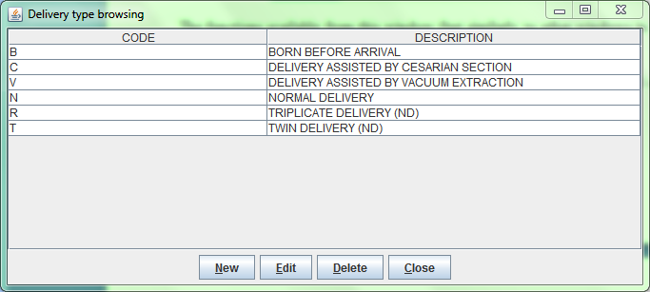

The functions available from this window (but similarly to other windows in ***Types*** menu) are:

* **New**: to enter a new type (cannot be used an already used code)
* **Edit**: to edit an already existing type (the code must be unchanged)
* **Delete**: to delete an already existing type (cannot be deleted if still used somewhere in the application)
* **Close**: to close the window

The Delivery Types defined in this functionality will be reflected in the Admission function (see Insert/modify Delivery data in this document).

### Delivery Result Types (Delivery Result Type)

Once you’ve pressed on **Delivery Result Type** buttonfrom the ***Types*** menu you access the ***Delivery Result Type Browsing*** window as showed below:

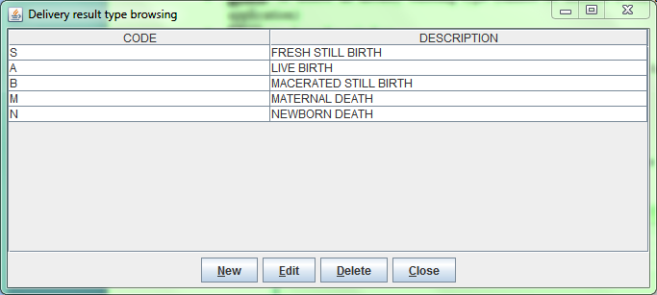

The functions available from this window (but similarly to other windows in ***Types*** menu) are:

* **New**: to enter a new type (cannot be used an already used code)
* **Edit**: to edit an already existing type (the code must be unchanged)
* **Delete**: to delete an already existing type (cannot be deleted if still used somewhere in the application)
* **Close**: to close the window

The Delivery Result Types defined in this functionality will be reflected in the Admission function (see Insert/modify Delivery data in this document).

### Disease Types (Disease Type)

Once you’ve pressed on **Disease Type** buttonfrom the ***Types*** menu you access the ***Disease Type Browsing*** window as showed below:

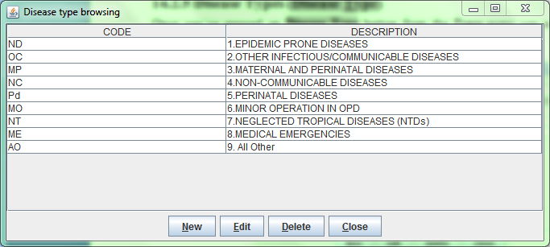

The functions available from this window (but similarly to other windows in ***Types*** menu) are:

* **New**: to enter a new type (cannot be used an already used code)
* **Edit**: to edit an already existing type (the code must be unchanged)
* **Delete**: to delete an already existing type (cannot be deleted if still used somewhere in the application)
* **Close**: to close the window

The Disease Types defined in this functionality will be reflected in the entire application, like in Disease definition or in OPD (see [Disease](#_Disease_(Disease)) and Create a new patient visit in this document).

### Exam Types (Exam Type)

Once you’ve pressed on **Exam Type** buttonfrom the ***Types*** menu you access the ***Exam Types Browser*** window as showed below:

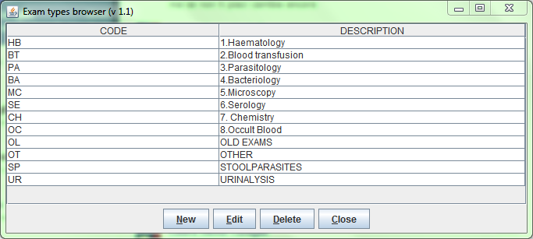

The functions available from this window (but similarly to other windows in ***Types*** menu) are:

* **New**: to enter a new type (cannot be used an already used code)
* **Edit**: to edit an already existing type (the code must be unchanged)
* **Delete**: to delete an already existing type (cannot be deleted if still used somewhere in the application)
* **Close**: to close the window

The Exam Types defined in this functionality will be reflected in the Laboratory function (see Laboratory in this document).

### Medicals Stock Movement Types (Medicals Stock Mov Type)

Once you’ve pressed on **Medicals Stock Mov Type** buttonfrom the ***Types*** menu you access the ***Medicals Stock Movement Types Browsing*** window as showed below:

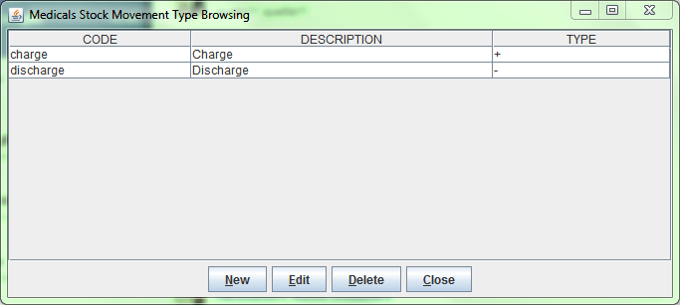

The functions available from this window (but similarly to other windows in ***Types*** menu) are:

* **New**: to enter a new type (cannot be used an already used code)
* **Edit**: to edit an already existing type (the code must be unchanged)
* **Delete**: to delete an already existing type (cannot be deleted if still used somewhere in the application)
* **Close**: to close the window

By pressing the **New** button you access the ***New*** ***Medical Stock Movement Type*** window as showed below:

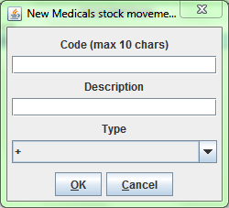

The allowed types are “+” and “-“ and this means that any kind of movements can be simplified as a charging (+) or a discharging (-) of the stock.

Examples could be:

* Positive correction (+)
* Negative correction (-)
* Donation (+)
* Lost (-)
* ...

The Medical Stock Movement Types defined in this functionality will be reflected in the Pharmaceutical Stock function (see Insert stock movement in this document).

### Medical Types (Medical Type)

Once you’ve pressed on **Medical Type** buttonfrom the ***Types*** menu you access the ***Medical Type Browsing*** window as showed below:

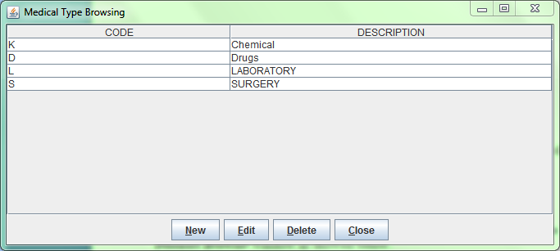

The functions available from this window (but similarly to other windows in ***Types*** menu) are:

* **New**: to enter a new type (cannot be used an already used code)
* **Edit**: to edit an already existing type (the code must be unchanged)
* **Delete**: to delete an already existing type (cannot be deleted if still used somewhere in the application)
* **Close**: to close the window

The Medical Types defined in this functionality will be reflected in the entire application, like in Pharmacy function and Pharmaceutical Stock Ward (see Insert a new pharmaceutical and Search Ward Pharmacy movements in this document).

### Operation Types (Operation Type)

Once you’ve pressed on **Operation Type** buttonfrom the ***Types*** menu you access the ***Operation Type Browsing*** window as showed below:

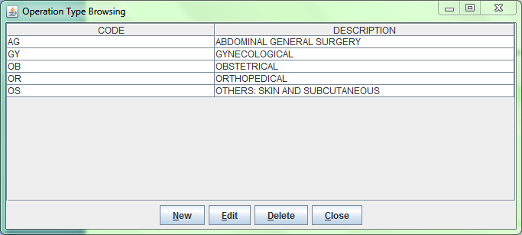

The functions available from this window (but similarly to other windows in ***Types*** menu) are:

* **New**: to enter a new type (cannot be used an already used code)
* **Edit**: to edit an already existing type (the code must be unchanged)
* **Delete**: to delete an already existing type (cannot be deleted if still used somewhere in the application)
* **Close**: to close the window

The Operation Types defined in this functionality will be reflected in the Admission function (see Insert/modify Surgery data in this document).

### Pregnant Treatment Types (Pregnant Treatment Type)

Once you’ve pressed on **Pregnant Treatment Type** buttonfrom the ***Types*** menu you access the ***Pregnant Treatment Type Browsing*** window as showed below:

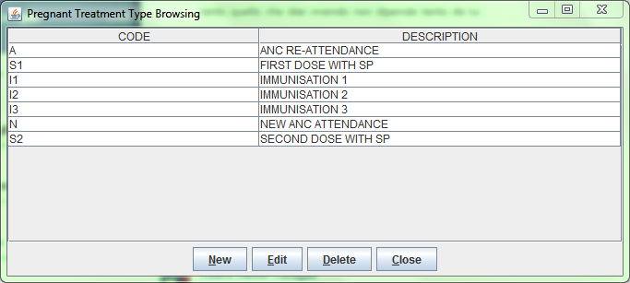

The functions available from this window (but similarly to other windows in ***Types*** menu) are:

* **New**: to enter a new type (cannot be used an already used code)
* **Edit**: to edit an already existing type (the code must be unchanged)
* **Delete**: to delete an already existing type (cannot be deleted if still used somewhere in the application)
* **Close**: to close the window

The Pregnant Treatment Types defined in this functionality will be reflected in the Admission function (see Insert/modify Delivery data in this document).

### Other Prices (Other Prices)

Once you’ve pressed on **Other Prices** buttonfrom the ***Types*** menu you access the ***Other Prices Browser*** window as showed below:

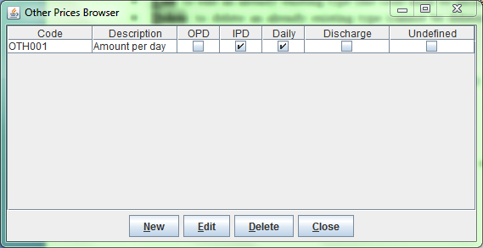

The functions available from this window (but similarly to other windows in ***Types*** menu) are:

* **New**: to enter a new price (can be used an already used code)
* **Edit**: to edit an already existing price (the code can be changed)
* **Delete**: to delete an already existing price (cannot be deleted if still used somewhere in the application)
* **Close**: to close the window

By pressing the **New** button you access the ***New*** ***Medical Stock Movement Type*** window as showed below:

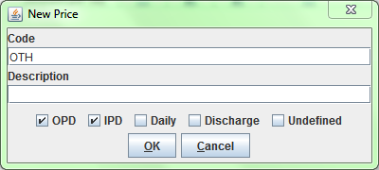

In order to insert a New Price you must input following data:

* **Code**: is the Price code and should be unique; anyway there are no restriction on this field since the application will use an internal code to identify univocally this item
* **Description**: the Price description that may include the code for a fast search
* **OPD**: if the price is applicable with OPD (not yet implemented)
* **IPD**: if the price is applicable with IPD (not yes implemented)
* **Daily**: if the price should be applied for every bed-day (not yet implemented) or just once; if checked, you will be asked for “how many days?” when using this item, with follow ***Days*** window:

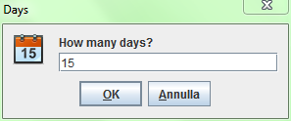

* **Discharge**: if the item has to be treated as a negative value so it will act as a discharge in the bill statement (ie. Charge-Off, Free-of-charge, etc...).
* **Undefined**: if the item have no value in the PriceList and the amount have to be set “on the fly” while editing a bill; if checked, you will be asked for “how much is it?” with follow ***Undefined*** window:

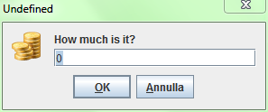

The Other Prices defined in this functionality will be reflected in the Accounting and PriceLists functions (see Insert a new bill and [Prices](#_Prices_(Price_Lists)) in this document).

### Age Types (Age Type)

Once you’ve pressed on **Age Type** buttonfrom the ***Types*** menu you access the ***Age Type Browser*** window as showed below:

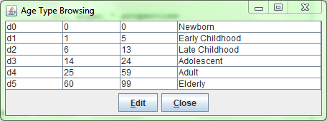

Since OpenHospital 1.7 age ranges are fixed and the Administrator can only change their values to best fit the health normative in the country.

By pressing the **Edit** button the table will allow you to modify only the age values and the button become a **Save** button now:

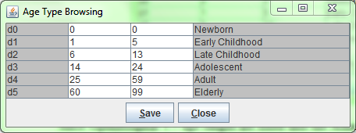

By double-clicking on each value you can change it by typing the new value. Then by pressing the **Save** button, the new informations will be stored in the system.

Only integer values are allowed and every range must be **contiguous** and not **overlapped** with the previous or with the following one:

For instance, in following case, ranges Late Childhood and Adolescent are not **contiguous** and ages 14 and 15 are not defined in any range:

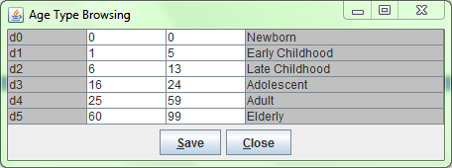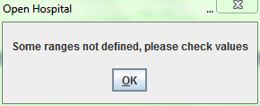

In following case instead, ranges Late Childhood and Adolescent are **overlapped** since both starts from age 6:

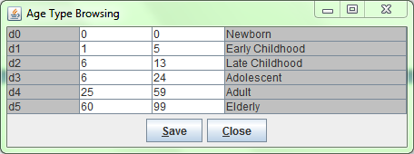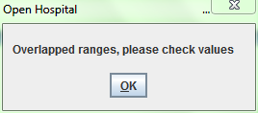

The Age Types defined in this functionality will be reflected in the Patient Extended functionality (see Insert a new Patient Extended in this document).

### Vaccine Types (Vaccine Type)

Once you’ve pressed on **Vaccine Type** buttonfrom the ***Types*** menu you access the ***Vaccine Type Browsing*** window as showed below:

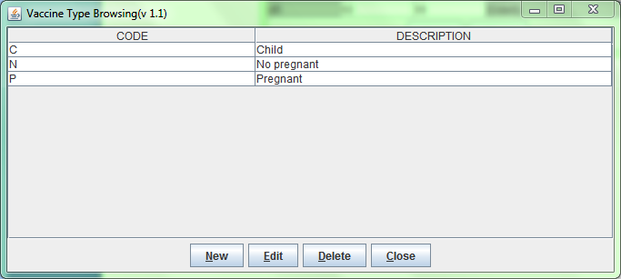

The functions available from this window (but similarly to other windows in ***Types*** menu) are:

* **New**: to enter a new type (cannot be used an already used code)
* **Edit**: to edit an already existing type (the code must be unchanged)
* **Delete**: to delete an already existing type (cannot be deleted if still used somewhere in the application)
* **Close**: to close the window

The Vaccine Types defined in this functionality will be reflected in the Vaccine function (see [Vaccines](#_Vaccines_(Patient_Vaccines)) in this document).

## Hospital (Hospital)

Once you’ve pressed on **Hospital** buttonfrom the ***General Data*** menu you access the ***Hospital informations*** window as showed below:

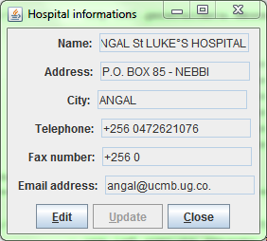

By pressing the **Edit** button the fields will allow you to modify the values and set the facility informations where you’re installing the software:

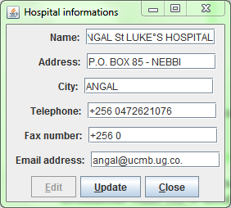

By pressing the **Update** button the new informations will be stored in the system and will be reflected in the entire application, like in reports heading (see [Statistics](#_Statistics_(Statistics)) in this document)

## Ward (Ward)

Once you’ve pressed on **Ward** buttonfrom the ***General Data*** menu you access the ***Ward Browser*** window as showed below:

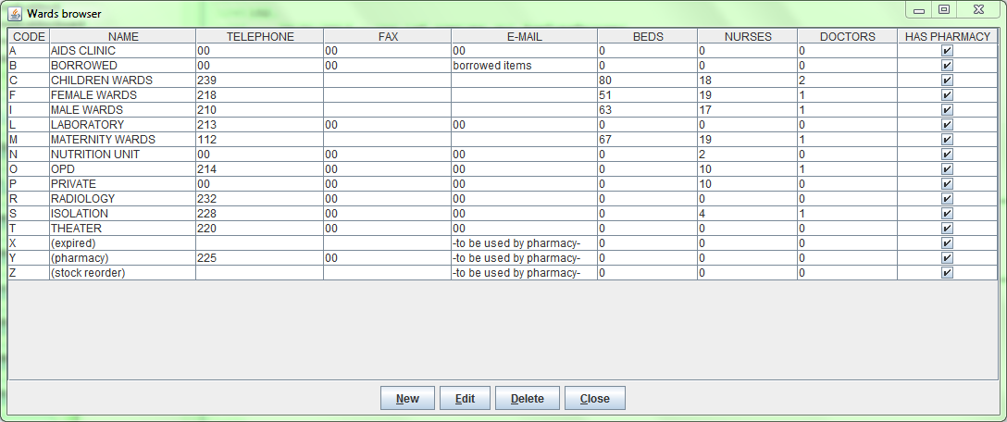

The functions available from this window (but similarly to other windows in ***Types*** menu) are:

* **New**: to enter a new ward (cannot be used an already used code)
* **Edit**: to edit an already existing ward (the code must be unchanged)
* **Delete**: to delete an already existing ward (cannot be deleted if still used somewhere in the application)
* **Close**: to close the window

By pressing the **New** button you access the ***New*** w***ard record*** window as showed below:

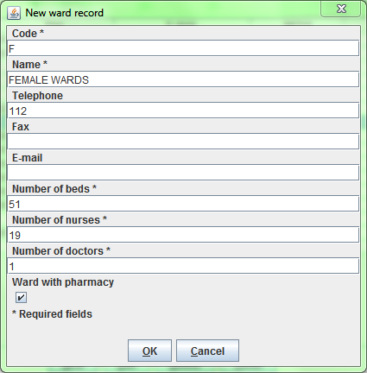

In order to insert a new Ward you must provide following compulsive inputs:

* **Code**: the ward code (it must be unique)
* **Name**: the name of the ward
* **Number of beds**: it will be reflected in the admission module to check available beds; 0 – zero beds wards will be not shown in the admission module
* **Number of nurses**: it may be reflected in some reports (0 – zero is allowed)
* **Number of doctors**: it may be reflected in some reports (0 – zero is allowed)
* **Ward with pharmacy**: it will be reflected in Pharmaceuticals Stock; if checked we are saying that this ward can be a destination for discharging movements, otherwise it will not shown in the list

***NB****: trough this function we may define some wards with 0 - zero beds but with pharmacy, in order to have “logic” departments (rather than physical) to manage pharmacy movements*

The Wards defined in this functionality will be reflected in the entire application, like in Admission module, Pharmaceuticals Stock and Pharmaceuticals Stock Ward (see [Admission/Patient](#_Admission/Patient_(Admission/Patien), [Pharmaceutical Stock](#_Pharmaceutical_Stock_(Pharmaceutica) and Pharmaceuticals Stock Ward in this document).

## Disease (Disease)

Once you’ve pressed on **General Data** buttonfrom the ***General Data*** menu you access the ***Diseases Browser*** window as showed below:

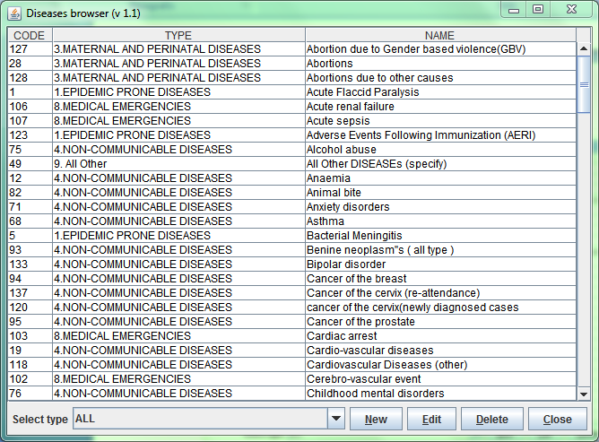

The functions available from this window (but similarly to other windows in ***Types*** menu) are:

* **Selected Type**: you may filter the list by selecting only one DiseaseType
* **New**: to enter a new disease (cannot be used an already used code)
* **Edit**: to edit an already existing disease (the code and type must be unchanged)
* **Delete**: to delete an already existing disease (it is set as not present in OPD neither in IPD)
* **Close**: to close the window

By pressing the **Edit** button, the ***Edit Disease*** window will appear as shown below:

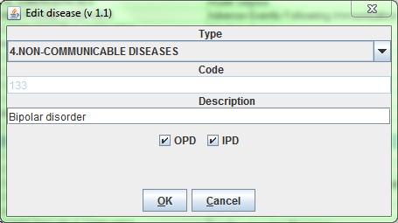

In editing mode you cannot change type and code but only modify the Description and specify if the disease should appear in OPD, Admissions or both.

By removing the check from both checkboxes OPD and IPD you are performing a **Delete** action, that is disabling it to appear anymore in the application. Anyway this can be changed anytime by editing it again.

The Diseases defined in this functionality will be reflected in the entire application, like in Admission module and OPD module (see [Admission/Patient](#_Admission/Patient_(Admission/Patien) and [Outpatient Department Management](#_Outpatient_Department_management(OP) in this document).

## Exam (Exams)

Once you’ve pressed on **Exams** buttonfrom the ***General Data*** menu you access the ***Exam Browsing*** window as showed below:

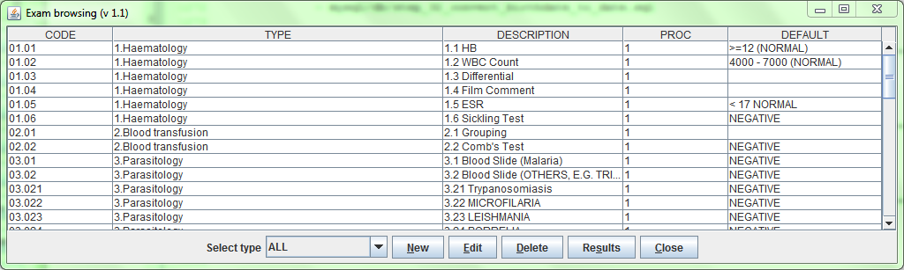

The functions available from this window (but similarly to other windows in ***Types*** menu) are:

* **Selected Type**: you may filter the list by selecting only one ExamType
* **New**: to enter a new exam (cannot be used an already used code)
* **Edit**: to edit an already existing exam (the code and type must be unchanged)
* **Delete**: to delete an already existing exam (it is set as not present in OPD neither in IPD)
* **Results**: to define possible results for the selected exam
* **Close**: to close the window

By pressing the **Edit** button, the ***Edit Exam*** window will appear as shown below:

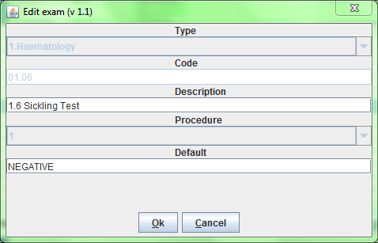

In editing mode you cannot change type, code and procedure but only modify the Description and the default value.

By pressing the **New** button, the ***New Exam*** window will appear as shown below:

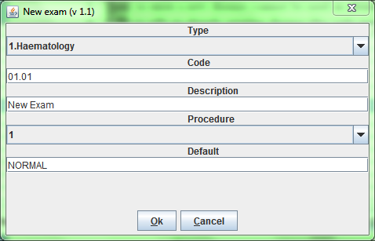

In order to insert a new Exam you must input the following data:

* **Type**: is the Exam Type (see [Exam Types](#_Exam_Types_(Exam) in this document)
* **Code**: you cannot use an already used code; a warning window will appear in case
* **Description**: is the exam name
* **Procedure**: the kind of results for this exam (see [Results](#_Results_(Results)) in this document)
* **Default**: a default value among the result we are going to define (see [Results](#_Results_(Results)) in this document)

### Results (Results)

Once you’ve inserted a new exam you may define the set of results it can allow by first selecting the exam in the ***Exam Browsing*** window and then by pressing on the **Results** button.

In OpenHospital 1.7 you can define two kind of set of results, called “Procedure”:

* **Procedure 1**: a set of values as description; only one will be selectable as exam **Single Result**
* **Procedure 2**: a set of Positive/Negative values; all of them will figure as exam **Multiple Results**

The difference between **Procedure1** and **Procedure2** will be seen in the Laboratory module (see Create a new laboratory exam and Laboratory Multiple Insert in this document)

So the two possibilities are showed below:

Procedure 1

Procedure 2

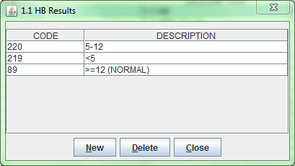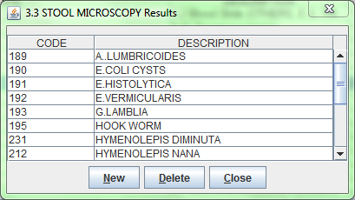

The functions available from both windows are:

* **New**: to enter a new result
* **Delete**: to delete an already inserted result
* **Close**: to close the window

## Operations (Operation)

Once you’ve pressed on **Operation** buttonfrom the ***General Data*** menu you access the ***Operation Browser*** window as showed below:

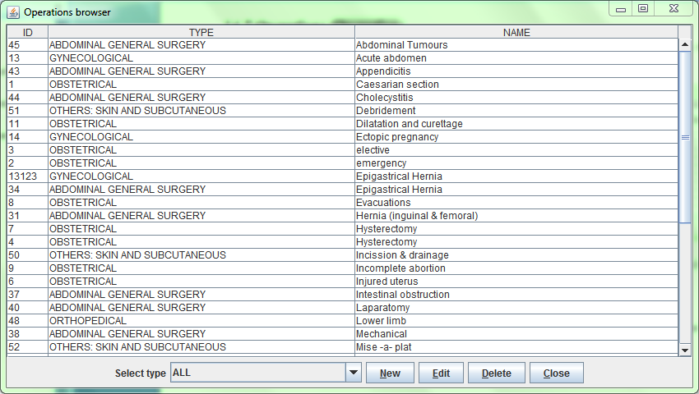

The functions available from this window (but similarly to other windows in ***Types*** menu) are:

* **Selected Type**: you may filter the list by selecting only one OperationType
* **New**: to enter a new operation (cannot be used an already used code)
* **Edit**: to edit an already existing operation (the code and type must be unchanged)
* **Delete**: to delete an already existing operation (it is set as not present in OPD neither in IPD)
* **Close**: to close the window

By pressing the **Edit** button, the ***Editing operation record*** window will appear as shown below:

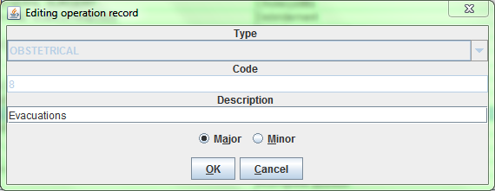

In editing mode you cannot change type and code but only modify the Description and specify if the operation concerns Major or Minor surgery for statistical purpose (not yet implemented).

The Operations defined in this functionality will be reflected in the entire application, like in Admission module (see Insert/modify Surgery data in this document).

## Vaccine (Vaccine)

Once you’ve pressed on **Vaccine** buttonfrom the ***General Data*** menu you access the ***Vaccine Browser*** window as showed below:

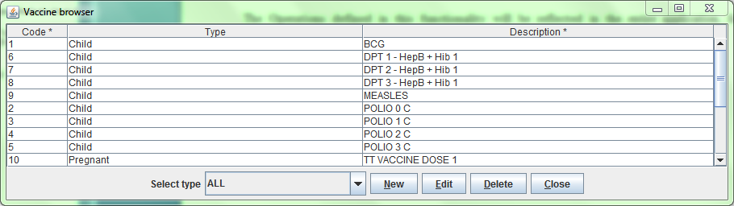

The functions available from this window (but similarly to other windows in ***Types*** menu) are:

* **Selected Type**: you may filter the list by selecting only one VaccineType
* **New**: to enter a new vaccine (cannot be used an already used code)
* **Edit**: to edit an already existing vaccine (the code and type must be unchanged)
* **Delete**: to delete an already existing vaccine (it is set as not present in OPD neither in IPD)
* **Close**: to close the window

By pressing the **Edit** button, the ***Edit vaccine record*** window will appear as shown below:

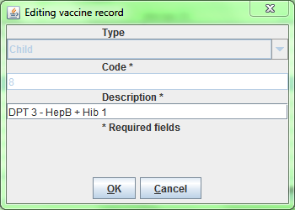

In editing mode you cannot change type and code but only modify the Description.

The Vaccines defined in this functionality will be reflected in the entire application, like in Vaccine module (see [Vaccines](#_Vaccines_(Patient_Vaccines)) in this document).

## Prices (Price Lists)

Once you’ve pressed on **Price Lists** buttonfrom the ***General Data*** menu you access the ***Prices Browser*** window as showed below:

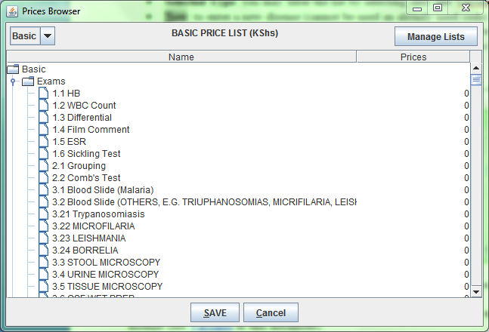

The functions available from this window are:

* **SAVE**: to save any modification made to the pricelist
* **Cancel**: to close the window
* Switch pricelist: you can focus on a different pricelist by selecting it on the upper-left corner of the window
* **Manage Lists**: you can define how many and which pricelist will be available in the application (see [Pricelists](#_Prices_lists_(Manage) in this document)

The ***Prices Browser*** window shows the list of all prices in the selected pricelists; the system automatically creates a price for every Exam (see [Exam](#_Exam_(Exams))), Operation (see [Operations](#_Operations_(Operation))) and Medical (see [Pharmaceuticals](#_Pharmaceuticals_(Pharmaceuticals))) defined in the system, plus other prices defined in Other Prices module (see [Other Prices](#_Other_Prices_(Other))

In order to modify a price just double-click on it and type the new price.

***NB****: if a price has been defined as “undefined” (see* [*Other Prices*](#_Other_Prices_(Other)*) it will look as 0 – zero and cannot be modified.*

***NB****: Exams, Operations and Medicals prices are automatically created as OPD, IPD, not “daily”, not “undefined”, not “discharge”; see* [*Other Prices*](#_Other_Prices_(Other) *for more information.*

When all modifications have been made, you can store them permanently in the system by pressing **SAVE** button. After some instants a confirmation message will inform you about the success of the operation:

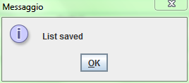

### Pricelists (*Manage Lists*)

Once you’ve pressed on ***Manage Lists*** buttonfrom the ***Prices Browser*** window you access the ***List Browser*** window as showed below:

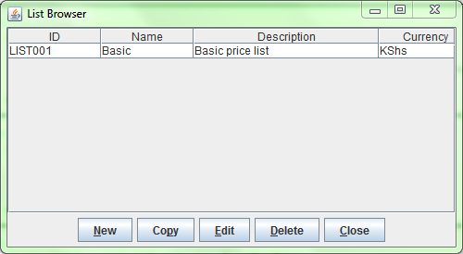

The functions available from this window (but similarly to other windows in ***Types*** menu) are:

* **New**: to enter a new pricelist
* **Copy**: to create a new pricelist as a copy of another one
* **Edit**: to edit an already existing pricelist
* **Delete**: to delete an already existing pricelist
* **Close**: to close the window

By pressing the **Copy** button, the application will guide you step by step by asking:

1. a **Name** of the new pricelist
2. a **Multiplier** for all prices in the selected pricelist
3. a **Rounding factor** for all prices in the new pricelist

Depending on the size of the selected pricelist, after some instants a confirmation message will inform you about the success of the operation:

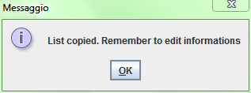

By default, the new list is created with following informations:

**ID**: “aCode”

**Name**: the name you provided in the step by step copying procedure

**Description**: “aDescription”

**Currency**: the same of the selected pricelist

Once the copy has been created you may want to change default information by editing the pricelist just created.

By pressing the **Edit** button, the ***Edit list*** window will appear as shown below:

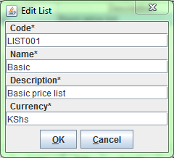

In editing mode you can change all data related to the list.

The Lists defined in this functionality will be reflected in the Accounting module (see Insert a new bill in this document).

# Users & Groups (File -> *Users*)

The User Menu can be enabled or disabledby changing the *SINGLEUSER* flag in the configuration file**.** Ask to your Administrator how to do it or read the *Administrator’s Guide*.

If *SINGLEUSER* is set to NO the following login window will appear when the program starts:

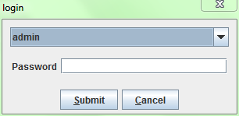

Once successfully logged in the system, you have been enabled by the administrator you will find the ***Users*** button in the ***File*** submenu.

Once you’ve pressed on ***Users*** buttonfrom the ***File*** submenu you access the ***Users*** submenu as showed below:

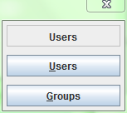

OpenHospital allows the management of users organized into groups; each group is characterized by different permissions assigned by the Administrator.

Before to register a new user in the system, we should ensure there is a group with its related rights, where the user can be added to.

## Groups (Groups)

Once you’ve pressed on **Groups** buttonfrom the ***Users*** submenu you access the ***Groups Browser*** window as showed below:

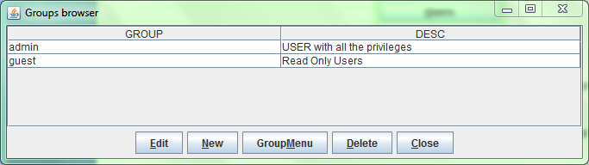

The functions available from this window are:

* **Edit**: to edit an already existing group (only description can be changed)
* **New**: to enter a new group
* **GroupMenu**: to define rights and permission on a selected group
* **Delete**: to delete an already existing group
* **Close**: to close the window

By pressing the **GroupMenu** button, the ***Menu Item Browser*** window will appear as shown below:

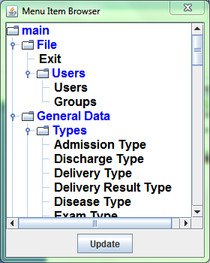

The window show the full set of function of OpenHospital in a tree format:

* main is the “trunk”: the main menu
* **Blue** nodes are the “branches”: menus and windows
* **Black** nodes are the “leaves”: buttons and functions

By double-clicking on each branch or leaves we can enable or disable that function or set of functions for the selected group.

For instance, the group “Registration Office” and the group “Cashiers” may have the following group permission configurations:

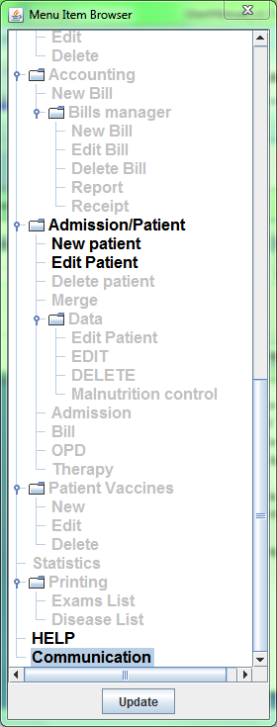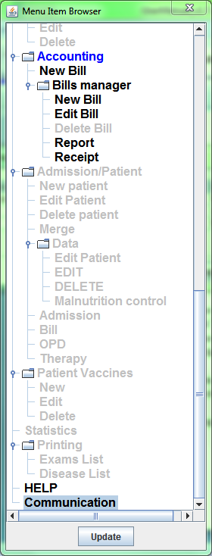

Registration Office Group

Cashiers Group

So the Registration Office group can only use the Admission/Patient module to insert and edit patients, while the Cashiers group can only use the Accounting module in order to produce bills. Both can run HELP (this guide) and Communication module.

So the “main menu” for each user registered in Registration Office group and for each one in Cashiers group will appears like following:

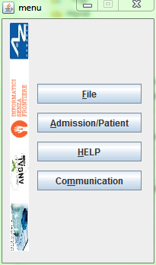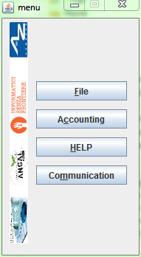

Registration Office Menu

Cashiers Menu

## Users (Users)

Once you’ve pressed on **Users** buttonfrom the ***Users*** submenu you access the ***Users Browser*** window as showed below:

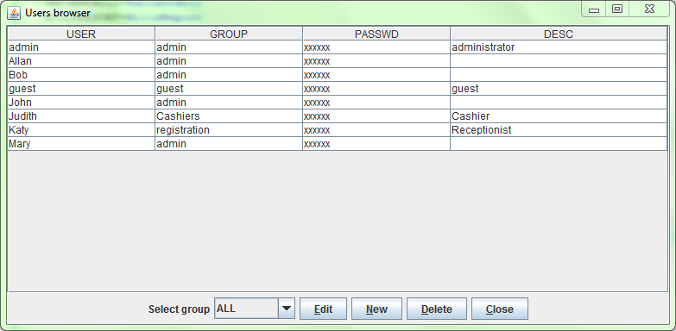

The functions available from this window are:

* **Selected group**: you may filter the list by selecting only one Group
* **Edit**: to edit an already existing user (the group must be unchanged)
* **New**: to enter a new user (cannot be used an already used name)
* **Delete**: to delete an already existing user
* **Close**: to close the window

By pressing the **Edit** button, the ***Editing user record*** window will appear as shown below:

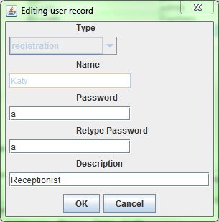

In editing mode you cannot change the type (group) and the name but only the password, that is in visible in this window.

Each user is so identified by a name, a description and a **password** that can be modified in any moment by the Administrator.

1. Informatici Senza Frontiere = Computer scientists without frontiers
2. Open-source = software for which the original **source code** is made available to anyone free of charge.